Timeline:
Summer 2020: Email all faculty about the assessment cycle and share SLOs with faculty currently on the schedule to teach in the Gen Ed categories that will be assessed that year. A reminder is included that the Gen Ed SLOs should be in every Gen Ed syllabus.
Fall 2020: Gen Ed program assessment cycle requests artifacts from courses in the Written and Oral Communication categories as well as the Culture and Creativity category. A repeat email was sent out in the first week of September to catch any late instructor assignments.
Sept 16, 2020: Instructors were emailed the randomly selected names of the students and their identification code who are to be assessed. If instructors need more information or new names (because a student is no longer in the class), please email Connie Kiskaden (kiskadenc@nku.edu).
December 16, 2020: Artifacts and a copy of the assignment should be uploaded to the General Education Canvas site, located under Assignments. See example below.
Spring 2021: Recommendation: develop a plan to provide assessment data at the course level to complement the data the Gen Ed Committee will provide for the Gen Ed category as a whole.
Summer 2021: All NKU Instructors will be invited to participate in scoring the Gen Ed artifacts. By the end of the summer, the Office of Undergraduate Affairs will share the Gen Ed findings for the Communication and Culture and Creativity.
Fall 2021: Each Gen Ed course in the Communication and Culture and Creativity course will need to submit a “Close the Loop” form documenting how instructors of each Gen Ed course will use assessment data (both from summer scoring as their own course level data to improve student learning. Due: November 1, 2021.
# # #
Help with Uploading into Canvas:
We know that faculty have more experience with creating assignments than submitting them as students. When you are ready to do so, first locate the email that Constance Kiskaden sent you on Sept 16th with the subject heading: General Education Assessment - Culture & Creativity (or Oral Communication or Written Communication) - List of Students by Instructor attached. You will need this to know which student artifacts to gather. Here is a step by step guide:
- On your Dashboard in Canvas, you should be able to find the Gen Ed shell. If you don’t see it, you may need to add the course (if so, email Emily (detmergoebel@nku.edu) and ask for an invite. If you already accepted the invite, look in the list of all courses.
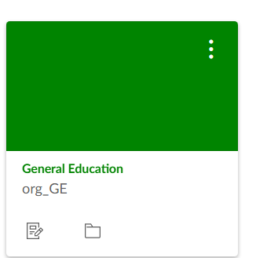

- Once you open the course, you should select Assignments.
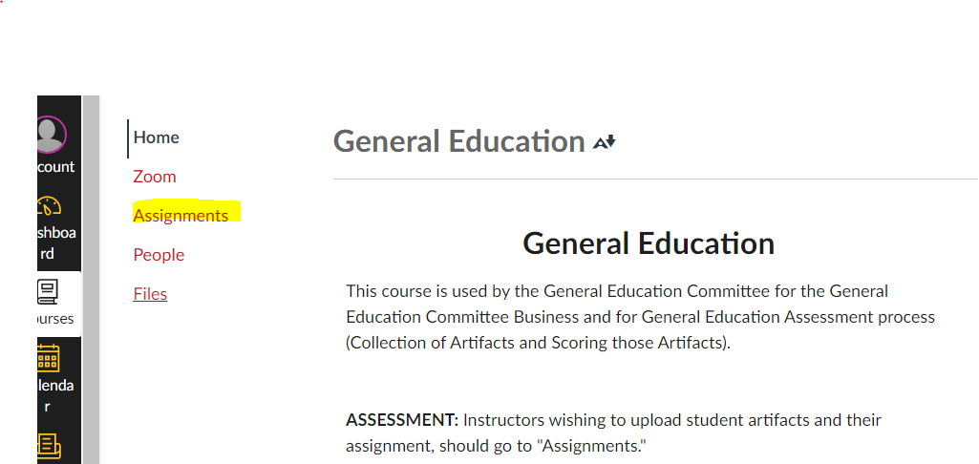

- At the top of the Assignments page, you will see “Upcoming Assignments.” Select the category in which you are ready to upload your assignment and student artifacts.

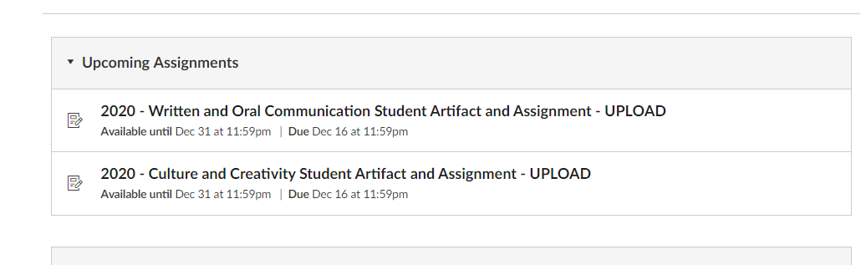
>>>>>>>>>>>>>>>>>>>>>>>>>>>>>>>>>>>>>>>>>>>>>>>>>>>>>>>>>>>>>>>>>>>>>>>>>>>>>>>.
On this page you will find information about the SLOs and how to upload the documents
DIRECTIONS FOR SUBMISSION IN CANVAS
Please make sure you have followed the naming convention for your files:
Naming the: Assignment File
  - Save and name a clean copy of your Assignment as follows:
    - CourseID-Assignment_SLO (being assessed)
Example: ENG200_002 -Assignment_SLO_A1_A4_B1_B2
Note: If you have more than one assignment being assessed in one course, please identify the SLO that is being assessed in each specific assignment.
Example: ENG200_002-Assignment_SLO_A1_A4
ENG200_002-Assignment_SLO_B1_B2
Naming the: Student’s Artifact File
  - Save and name the student’s artifact file as follows:
Example: Random#_CourseID_Student_Name_(SLO to be Assessed)
Note: If you have more than one SLO being assessed on one student’s submission, please identify all SLOs being assessed.
Example: CC678246_ENG200_002_Erica_Norse_A1-A4-B1-B2
WC678246_ENG101_001_Erick_Norse_C1-C2-C3W
- Before you submit the documents, you will need to have them saved outside of Canvas using the file name format highlighted in green above.
Downloading Assignments: You may have never downloaded an assignment from your own course in Canvas in order to upload it somewhere else. Just look for the icon on the far left hand of the actual document. Once the document is open on your desktop, change the name of the file to match the naming conventions mentioned above and save it.
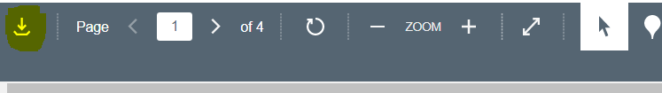

- Once you are ready to upload documents, use the Submit Assignment button. 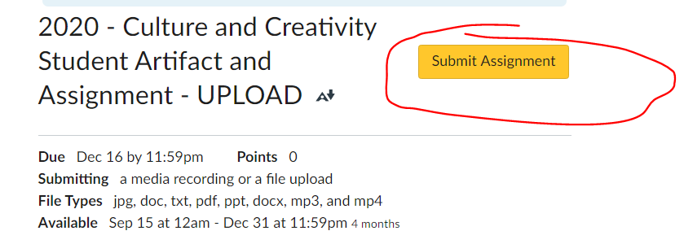

- Use the “Choose File” for the first document and then the “+Add Another File” for the rest of the files. You continue to upload documents until you have them all.

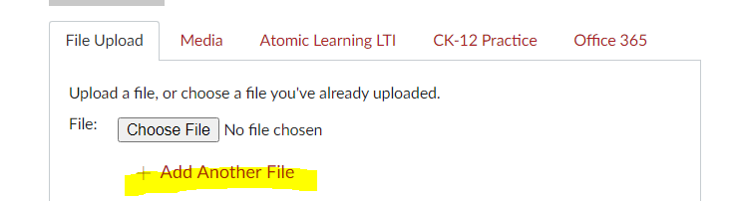

- At the end of the page and use the gold “Submit Assignment” button again.

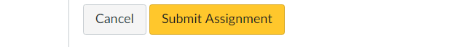
Here’s an example of what it will look like:
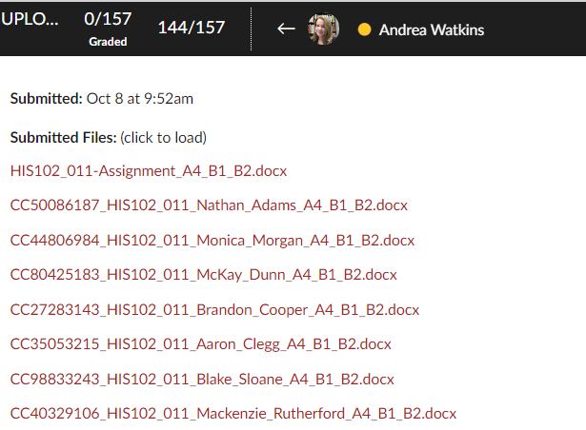
- Congratulations! You’re done.
# # #
The Final Step of the Process in the Cycle
The Close the Loop form is the final step of the assessment cycle where programs take into account the assessment data provided in the summer regarding a whole Gen Ed category as well as internal data that each program collects about their course. We ask that programs create an assessment plan for each course in the Gen Ed program every three years.

