Course Title
Section, time, location, etc.
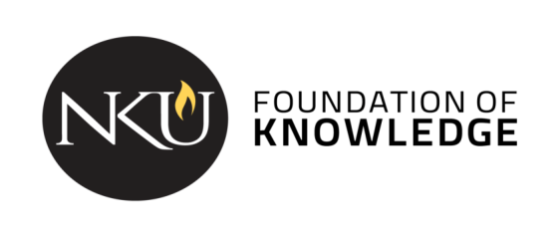

Course description: [insert catalog description]
The General Education Program at Northern Kentucky University guides students to become independent learners, innovative thinkers, and responsible citizens. The program gives students a foundation of values, knowledge, and skills that will empower them to discover their personal potential, communicate effectively, work in diverse communities, and solve problems in a global society. Courses in the program will invite students to expand the life-long practice of asking questions, seeking new points of view, applying principles of reason, adjusting ideas in relation to new situations, and taking reflective action.

Student Learning Outcomes
[Course name] is a course that partially fulfills the Cultural Pluralism category. As part of the general education curriculum, all students in this course will be directly assessed on the following outcomes:
- Students compare cultures from historical, local, national, or global perspectives. [B1]
- Students demonstrate how literature, the arts, and/or artifacts reflect and influence culture. [B2]
- Students demonstrate an understanding of the factors that influence global awareness. [E2]
In addition to the general education program outcomes, the following outcomes will also be addressed:
[Insert course specific outcomes]
The remainder of the syllabus should adhere to the university’s syllabus template for all courses: Syllabus template from the Provost’s website

