Course Title
Section, time, location, etc.
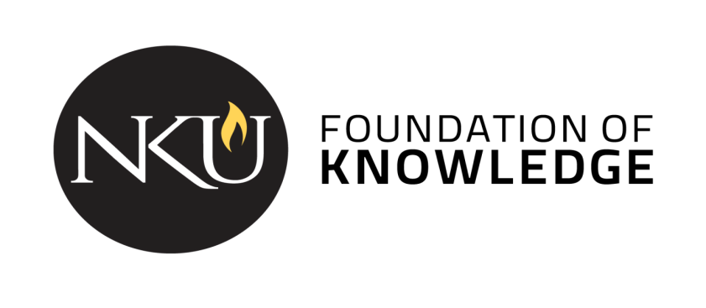

Course description: [insert catalog description]

The General Education Program at Northern Kentucky University guides students to become independent learners, innovative thinkers, and responsible citizens. The program gives students a foundation of values, knowledge, and skills that will empower them to discover their personal potential, communicate effectively, work in diverse communities, and solve problems in a global society. Courses in the program will invite students to expand the life-long practice of asking questions, seeking new points of view, applying principles of reason, adjusting ideas in relation to new situations, and taking reflective action.

Student Learning Outcomes
[Course name] is a course that partially fulfills the Mathematics category. As part of the general education curriculum, all students in this course will be directly assessed on the following outcomes:

- Students develop evidence-based solutions and/or conclusions. [A3]
- Students demonstrate the ability to use the appropriate (i.e. scientific, quantitative, computational, technological) methods/procedures and/or reasoning to draw an appropriate conclusion or solve a problem. [D1]

In addition to the general education program outcomes, the following outcomes will also be addressed:

[Insert course specific outcomes]

The remainder of the syllabus should adhere to the university’s syllabus template for all courses: syllabus template from the Provost’s web page.

