Adding an Honesty Statement to Exams

Why use an Honesty Statement?
Adding an academic honesty statement to exams can function as a good reminder to students about what is and what isn’t dishonesty behavior. Academic honesty statements should be both brief and clear.
Two example statements could be:
“Please type your name in the space below to acknowledge that you understand and will abide by the NKU Honor Code prohibiting cheating or dishonest behavior on this test.”
“You must abide by the NKU Honor code while taking this test. This means you will not cheat by communicating with other students, using outside resources like the internet, textbook, or notes, and you will not share information about the test with others afterwards. Type your name in the space below to acknowledge you understand.”
The former assumes the students are aware of the NKU Honor Code. The latter attempts to share a few specific examples of dishonest behavior that students shouldn’t do, which may make it more appropriate for a first-time student. You may want to tailor your statement based off of your course or college guidelines.

How to add an honesty statement
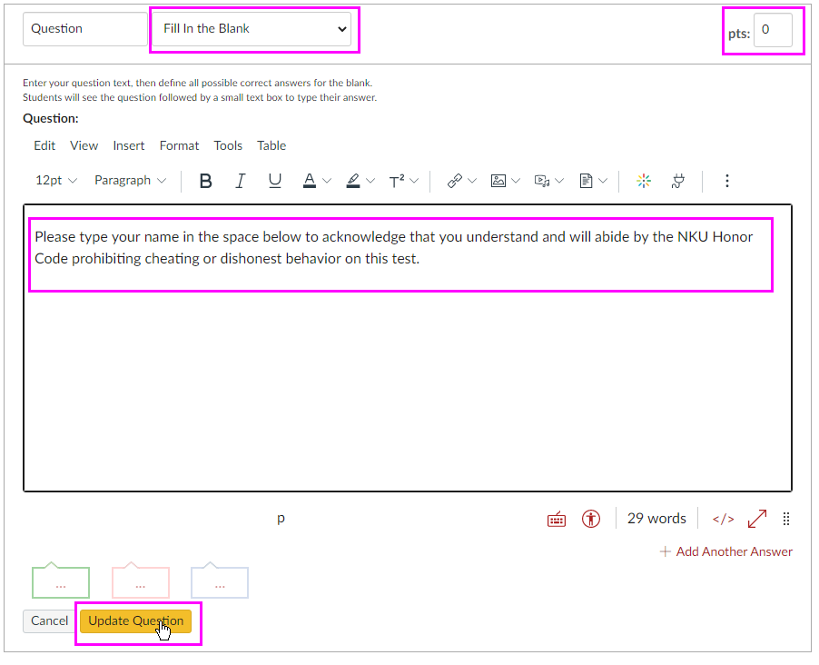
- Open the Quiz you want to add the statement to
- Select the “Questions” tab
- Select “+ New Question”
- In the Question type drop-down, select “Fill In the Blank” (instead of Multiple Choice)
- In the “Pts:” field, change it from 1 to 0. This will ensure students neither gain or lose points for this question.
- In the “Question:” field, type your academic honesty statement.
- Select the gold “Update Question” button
- Select the gold “Save” button to save your changes

