Voice Thread Request and Setup:

How to enable VoiceThread in your course:

Contact Lori Mcmillin:mcmillinl1@nku.edu with the course you would like to use VoiceThread. Note that VoiceThread needs to be enabled at admin level for each course, so if several courses need it, please provide all course IDs.

How to add VoiceThread content in your course:

Once you are notified that VoiceThread is enabled in your course, login the course and think about how do you want to use it. There are two main kinds of activities you can create with VoiceThread.

Non-graded activities:

- Navigate to the “Modules” area of your course.
- Find the module to which you’d like to add VT, and click the “Add Content” button.
- Select “VoiceThread” from the list of tools.
- Give your link a title.
- Save
- Click on the VT link you have just created, and further specify what you want to do with it. There are three options you can choose from, and they are used for different purposes:

- For Course View, it creates a link that opens up the VT Course view where you can see all the recordings that are shared with this course. This is a good option if you want to allow students to review all course materials prior to an exam.

For Home, it opens up users’ VT home page where it shows all the videos that specific user has created or shared with across all courses. It is useful when you want to create a simple portal into VoiceThread without directing students to any specific content.

For individual VT, when student click on the link, it takes the user straight to the recording without having to go through a collection of VoiceThread recordings.

Graded activities:

If you would like to create VT assignment where students can submit videos or audios for scores, you might need to create a Canvas assignment first. Then in the assignment submission type area, we choose external tool then select VoiceThread.

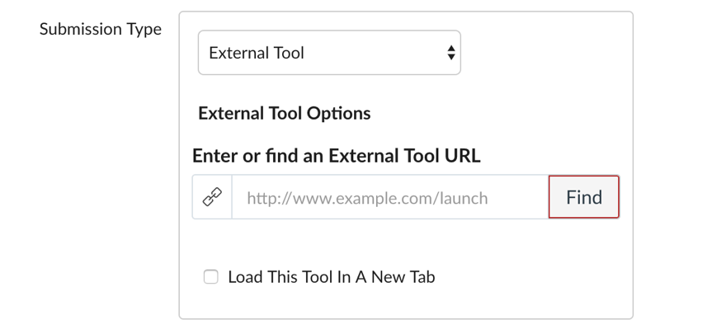

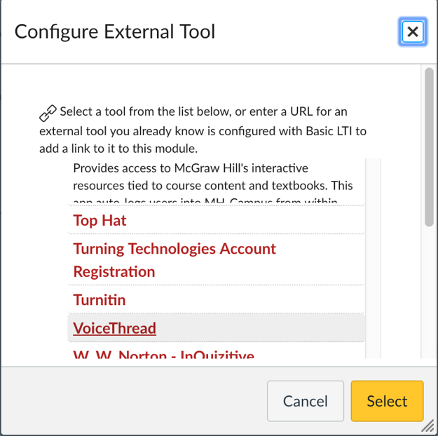

In the pop-up window, we choose Assignment Builder.

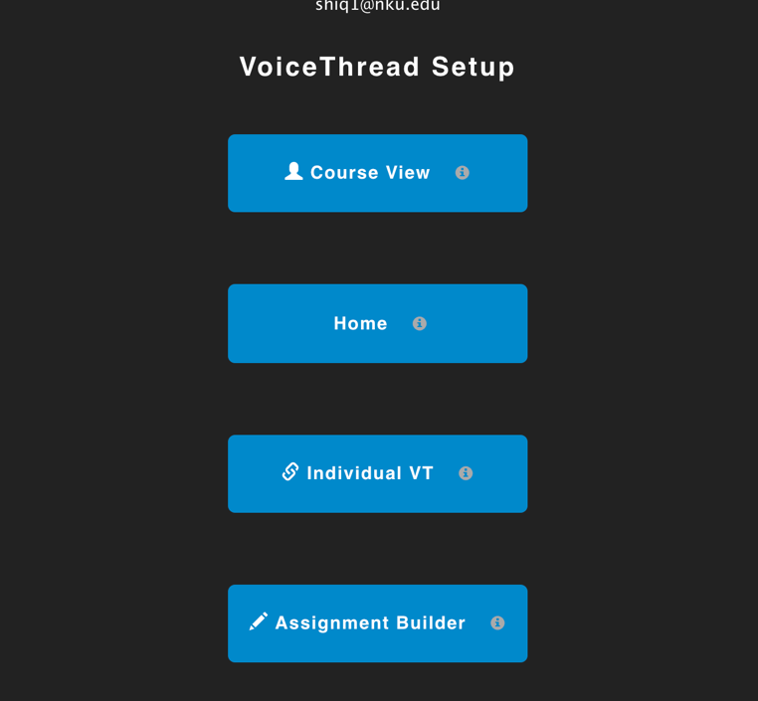

Three options you can choose to specify your assignment:

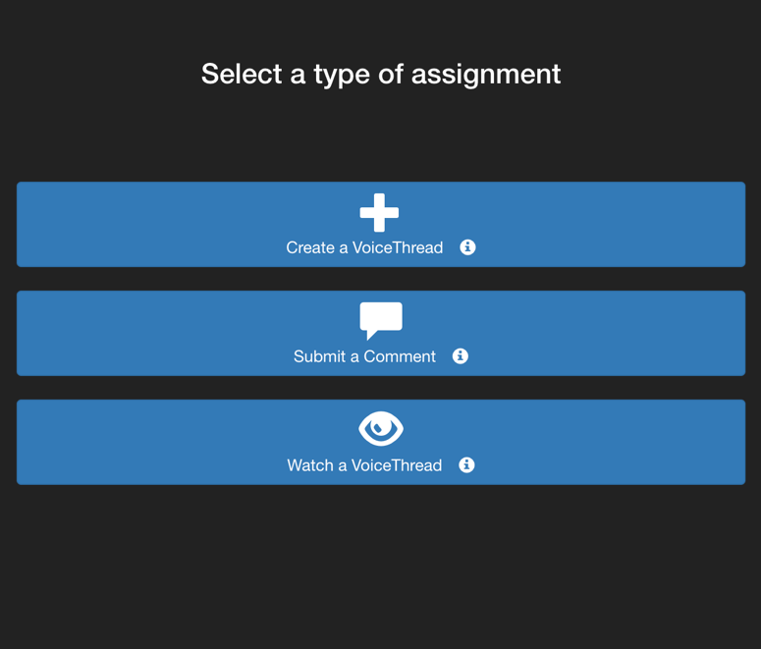

- Create a VoiceThread: create a VoiceThread of students own to submit.
- Submit a Comment: comment on a VoiceThread recording you’ve created.
- Watch a VoiceThread: simply watch a VoiceThread video to gain points.

After you’ve selected the type of assignment, you will be walked through the steps to complete the setup process.

Student submission:

Here is a tutorial for students on How to submit an VoiceThread assignment. Feel free to copy it into your VT assignment as part of the instruction.

Tip: Be sure to remind your students to check the box to “share with class” if you want your students to see each other’s submissions.

Grading student work:

Click on the assignment link we have created previously and it takes you to the VT assignment page where you can see student submissions on your right hand menu. Tab on the student name to enter the percentage and student work will play. The percentage will turn into points or the way you set up in your Canvas assignment and show up in your Canvas Grades.

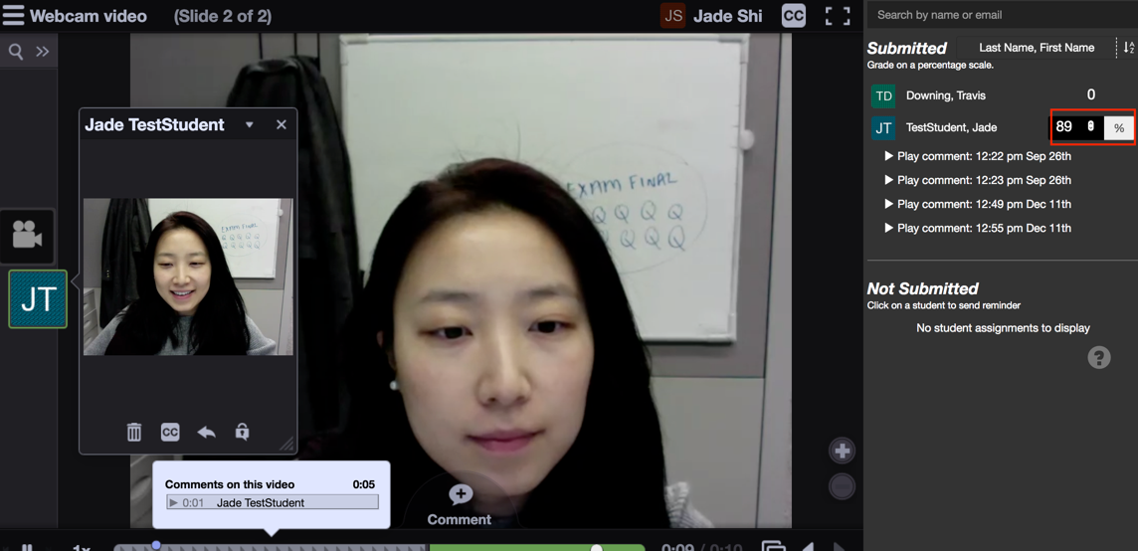

For more information about VoiceThread set up, check out the VT website.

