How to check for Services that Interact with Canvas
1. In a Canvas course, click Settings (in the left sidebar).
2. Click the Navigation tab.
3. If you see a service or textbook integration listed that is set to be visible to students or is set to not be visible to students, then the service already interacts with Canvas. Scroll to the end of the page to view the entire list.
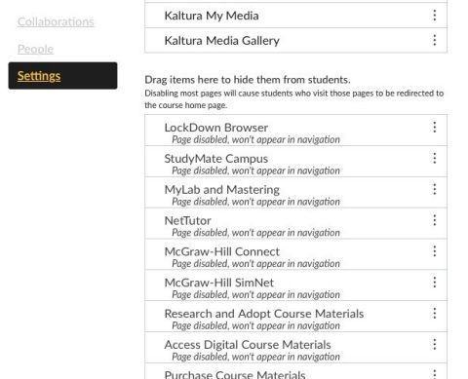

4. Some services do not have the product name in the title, so please view some services you have questions about.
5. If you make any changes to this page, click Save.
6. To check and see if a service that is not on the Navigation tab interacts with Canvas, click the Apps tab. Here is the link for instructions for using the App Center
7. If you try to add an App to Canvas and are asked for a Consumer Key or Shared Key, please contact CITE.

