How to Contact Students in an Unpublished Course

Many instructors choose to message their students before a course starts. For example, you might message your students in advance to make sure they know which textbook to buy. To do this in Canvas, your course must be published. However, you may not be ready for students to access your content or assignments yet.
To be able to message your students without letting them into your course early, go to the Settings area of your course and select Course Details. Follow these steps:
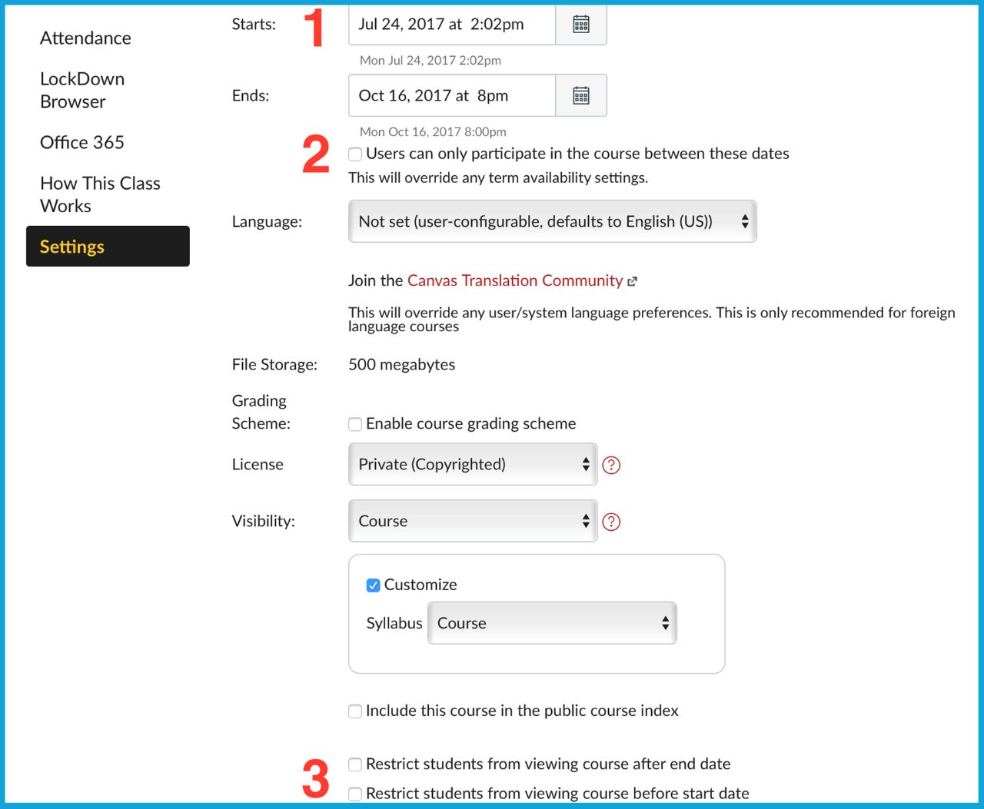
- Set a course start date. This is the earliest you want students to be able to enter your course.
- If you want them to access your course early but not submit assignments or quizzes, check the option Users can only participate in the course between these dates. Students will be able to access content, but not submit anything.
- If you do not want students to access any part of your course early, check the option Restrict students from viewing course before start date.
- Now you can use your Canvas Inbox to connect with your students before class begins.

