How to copy grades to myNKU
While you can still enter midterm and final grades manually into myNKU, you now have the option of copying your grades a class at a time. This guide has four sections: how to prepare your course in Canvas, how to copy your grades over, special cases for copying grades, and finally some error messages and what they mean.

Initial Setup
These steps can be completed at any time, even before the course has started.
- Enter your course, then navigate to Settings > Course Details > Grading Scheme. Check the box for “Enable course grading scheme.”
- The option to “view grading scheme” or “set grading scheme” will appear. Select that option.
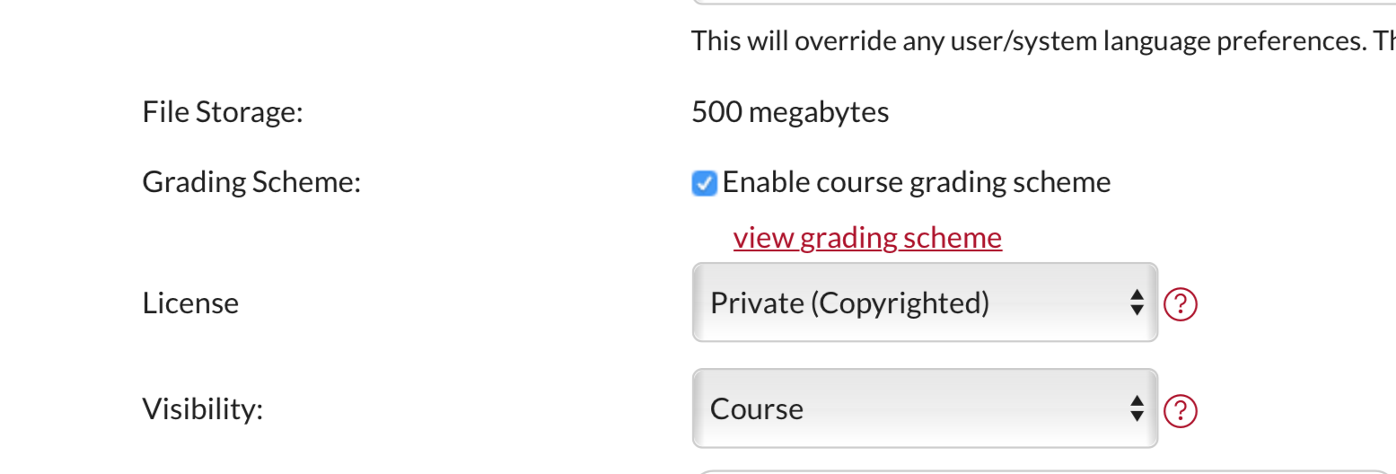
- A new window will pop up. If the window lists NKU’s grade scheme, you can choose “Done.” Otherwise, choose “Select another scheme.”
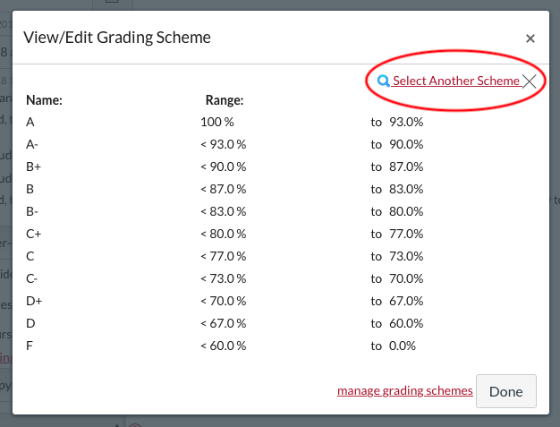
- 4. Choose NKU Letter, then “Use this grading standard,” then “Done.” Scroll to the bottom of the page and choose “Update Course Details.”
- Scroll to the top of the page and choose “Navigation.”
- Scroll down and locate the option “Canvas SAP Grade.” Select the three dot menu to the right of this option and choose “Enable.”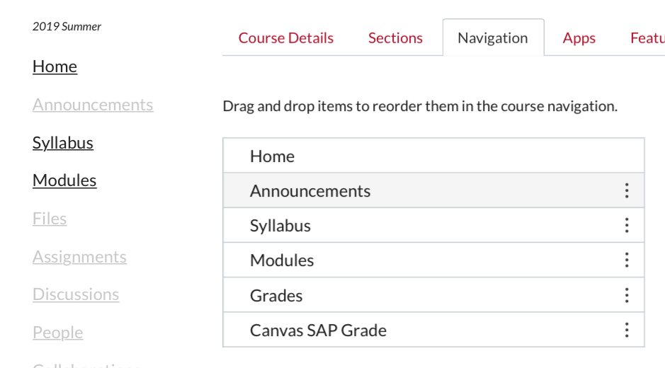
- Canvas SAP Grade should now be listed with the other parts of your course navigation. Scroll to the bottom of the page and click “Save.”

Using Canvas SAP Grade
Follow these steps at midterm and when you submit your final grades. Some of these screenshots reference Blackboard, but the steps are identical for Canvas.
- Make sure that every student has a grade for every assignment. If a student didn’t turn in work, you need to give them a 0 if you want that to be reflected in their final grade.
- Check the Total column of your gradebook. If the Total column does not list a letter grade next to student scores, go to the beginning of this document and complete the first set of instructions.
- Choose “Canvas SAP Grade” from your course navigation. A new tab or window will appear and load the myNKU grade window. A hyperlink will be available to select if your browser blocks pop-ups.
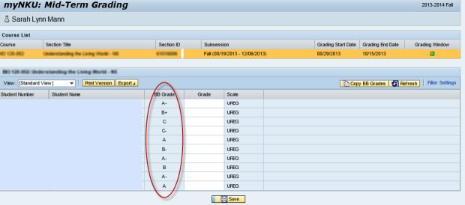
- This new window will show you which class you are viewing. At the bottom of the window will be your grades as they appeared in the Total column in Canvas.
- Verify that the grades are correct. Then click the “Copy Canvas Grades” button. The grades should now appear in the white column as well. At this point you can manually change grades if you wish. Changes made here will only go to myNKU and will not be reflected in Canvas.
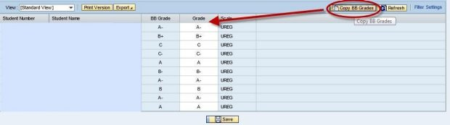
- Click the Save button at the bottom of the myNKU window to submit your grades to myNKU. A confirmation window will appear. Click OK.
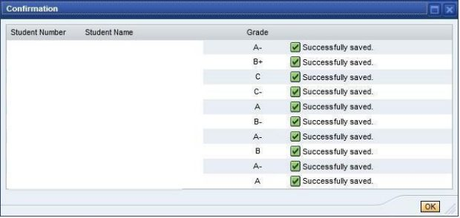

Important Notes
This method of copying grades will not work for students who match any of the following:
- The student is auditing a course.
- The student’s record is locked or marked incomplete (Contact the University Office of the Registrar).
Merged courses will display all of the sections you merged at the top of the myNKU grading window. You will need to select each section and copy their grades.
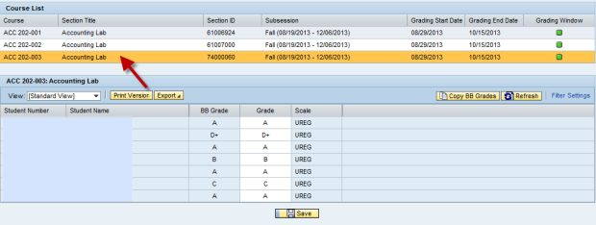

Possible Error Messages:

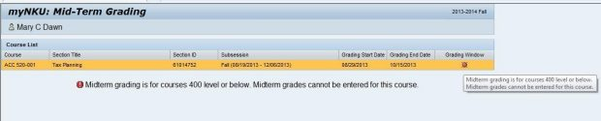
- Only courses under the 500 level submit midterm grades.
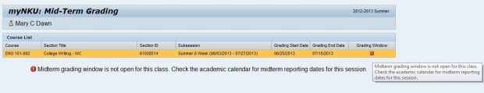
- Trying to submit after the grading window has closed produces an error message. Grade deadlines are listed in the NKU academic calendar on our website.
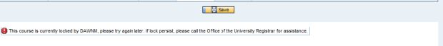
- The course will be locked if another instructor has it currently open in myNKU.

