How to Give Extra Attempts on Quizzes
Do you need to setup a student accommodation, or unlock a quiz for one student after the rest of the class has taken it? The Moderate This Quiz function of Canvas lets you do both.
1. In a Canvas course, click Quizzes (in the left sidebar).
2. Click the name of quiz you wish to change.
3. On the right, click Moderate this Quiz.
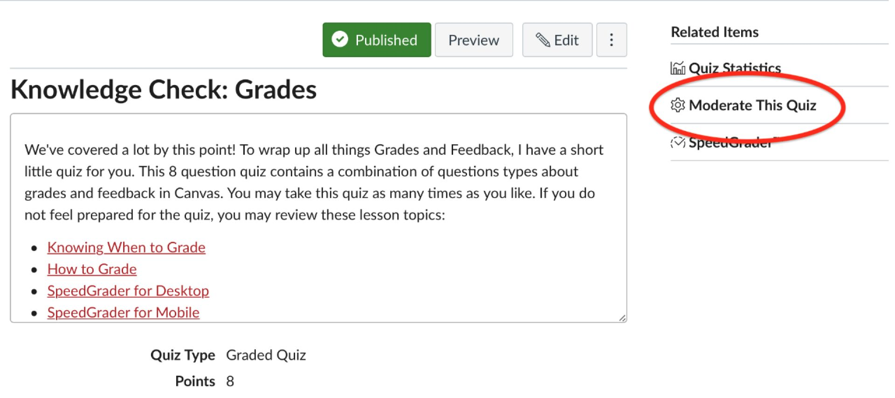
4. You will then see a screen that lists every student in the course. You can also see how many times the student has taken the quiz, how much time they spent taking the quiz, and their grade.
5. To setup a student accommodation, scroll down to the name of a student, or type the name of a student in the search box (top of the screen) and click Filter.
6. Click the Pencil icon to the right of the students name you wish to change.
7. Depending on the options you choose for this quiz you may see the option to grant additional attempts. If your quiz has a time limit, you’ll be able to extend that time limit. The last option will let you unlock the quiz for this student.
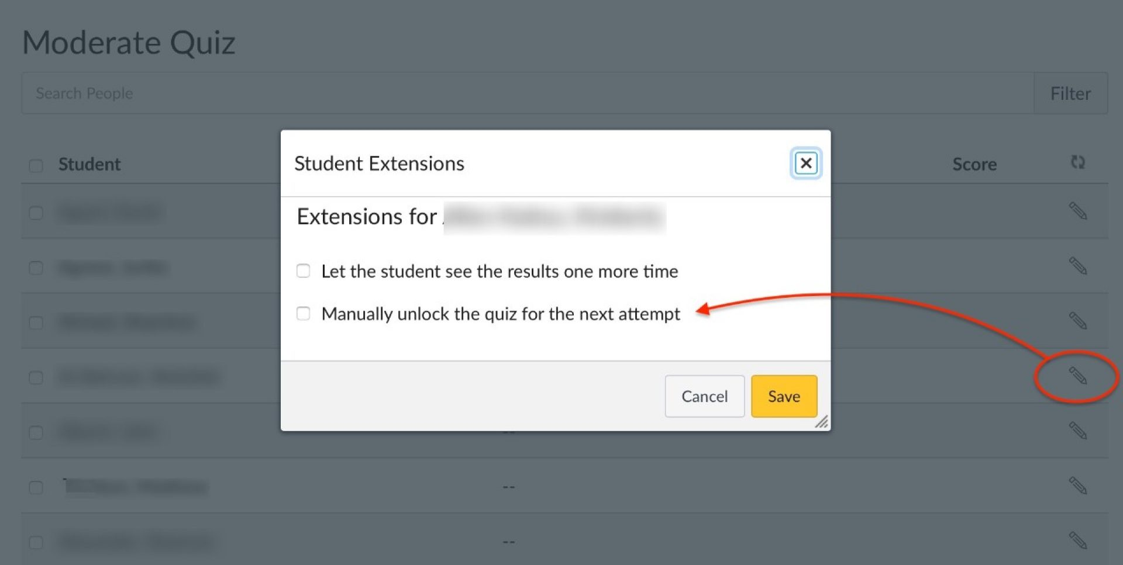
8. Click Save.

