Import Content from another Canvas Course

Select Specific Content
Important Note: If you have an active course for Step 3 choose Select Specific Content if you only want a few files as selecting All content can add a lot of extra information you do not want and can be cumbersome to remove.
- Go to the Settings area of your course, then click on Import Course Content
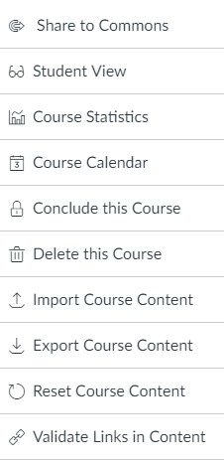
- For content type choose Copy a Canvas Course and some additional options will appear. Next to Seach for a course start typing in the course ID of the course that has the content you would like and it should appear for you to choose.
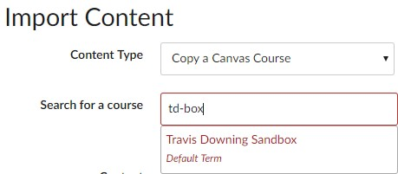
- For Content you will decide if you want everything that is in that course by selecting All Content, or just specfic things like quizzes or files by choosing Select Specfic Content. You should only choose All Content when your course is blank and you want to have content to edit that is similar to that course. After that hit Import.
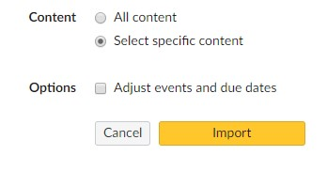
- A progress bar will appear at the bottom, when finished choose Select Content.
- You should now see everything that is inside that course. If you want everything from a particular section like Files, Modules, or Quizzes you can check the box next to it.
- If you want individual files or quizzes and not all of them hit the arrow next to the group and the file list will appear, check the ones you want and then hit Select Content when finished.
