Setting Levels of Availability in your Course

Canvas gives you the flexibility to determine how available or unavailable you wish to make your course. For example, you may wish to email your students before your course is published.
Four settings determine availability:
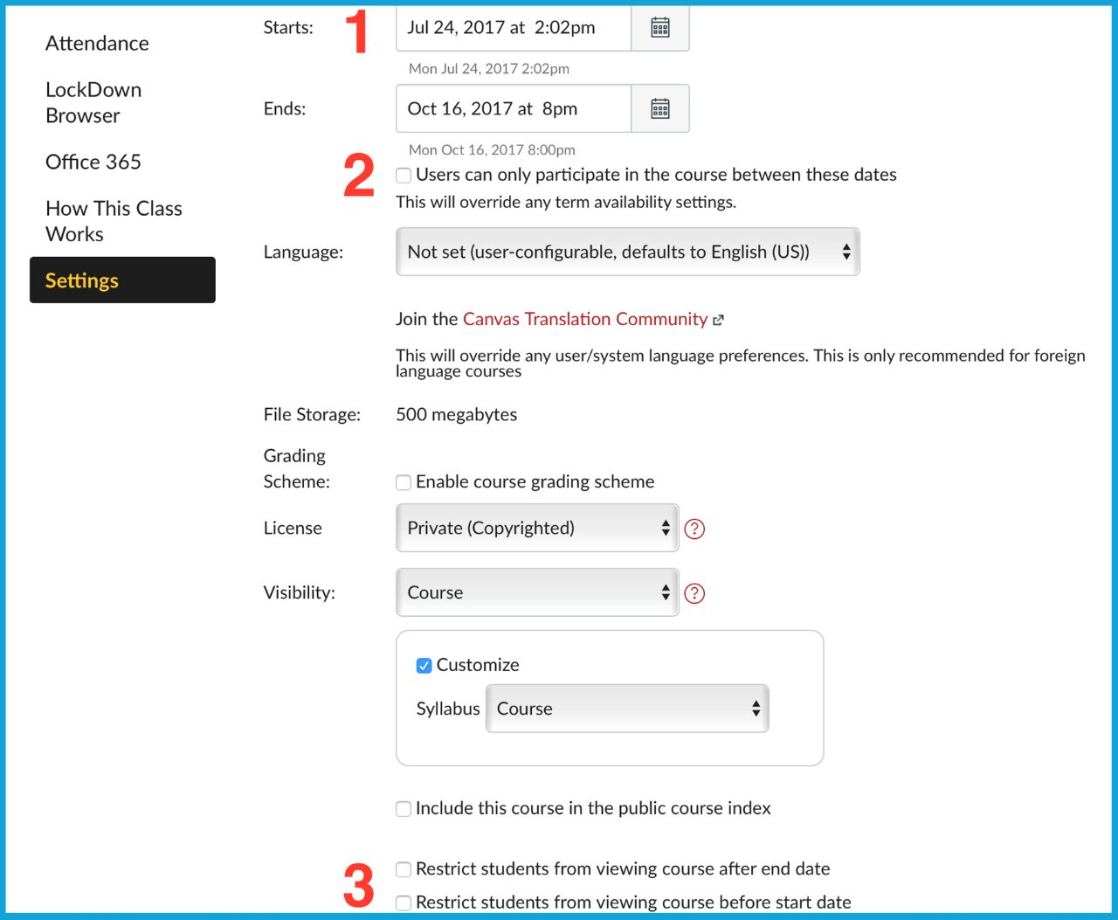
1. Starts and Ends Date: This setting can determine when content is available to students. Note: Setting these dates without making any other changes does not change your student’s ability to participate in your course.
2. Users can only participate in the course between these dates: If you place a checkmark in this checkbox, students can only participate (ie. take a quiz) between the Starts date and Ends date. Students can still view content in your course before and after these dates, but they cannot actively participate in your course.
3. Restrict students from viewing course after end date and before start date: If you place a checkmark in this checkbox, students will only be able to view and actively participate in your course between the Starts date and Ends date. Note: They cannot view any content before or after these dates.
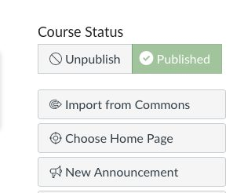
4. Published or Unpublished (course level): This setting determines the student’s ability to enter or not enter the course. When you click on Publish, students can actively participate in your course (i.e. take a quiz). If specific areas of your course are unpublished (such as a Discussion), they are not available to students.
For example, the most “controlled” scenario (while still publishing your course) would be to only make content available between a start date and end date. To do this:
1. Enter dates next to Starts date and Ends date.
2. Place a checkmark in the checkbox next to Users can only participate in the course between these dates.
3. Place checkmarks in the checkboxes next to Restrict students from viewing course after end date and Restrict students from viewing course before start date.
4. Click Update Course Details.

