Updating your class from Tegrity to Kaltura

IT is migrating all your videos to Kaltura from Tegrity. This means that all that’s left is to update your course so that videos display correctly to students. This is a two-step process: removing the Tegrity link, and then adding the Kaltura video.

Removing a Tegrity Link

Your Tegrity recording will either show up as a link or as a video students can click. To remove the video, place your cursor at the end of the link and hit backspace until the link is gone, just like you would delete words that you’ve typed.
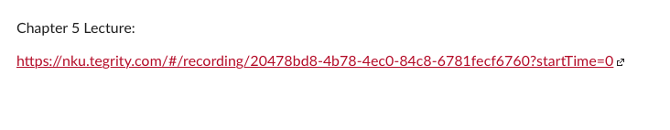

Adding a Kaltura Video

We are going to use the Kaltura button to add your video back by clicking the Kaltura icon, it looks like this:
You can access it by going to any Announcement, Assignment, or Page and clicking Edit.

Once you’ve clicked Edit, place your cursor where you want your video to appear. Click the blue drop down arrow , then Embed Kaltura Media button. 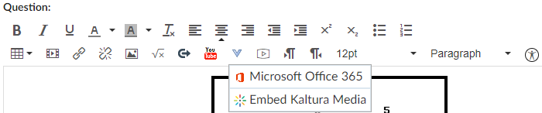
A window will pop up listing all your recordings. Videos moved over from Tegrity will all start with a course ID telling you where they came from. For example, any videos recorded for a speech class would start with CMST-101. Find the video you want and click Select.

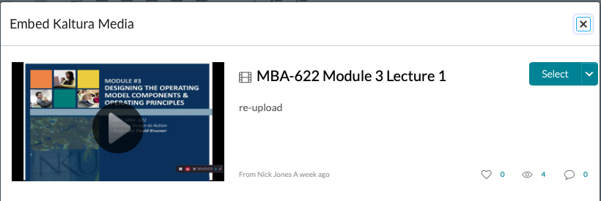
Now hit save and your video should be viewable to your students. If you have any issues, please call Travis Downing at CITE for assistance at x7946.

