Create a Turnitin Assignment

The current integration of Turnitin with Canvas allows instructors to automatically check for plagiarism once students submit a File Upload or Text Entry assignment. All configuration is done completely within Canvas.

- Go to your course and create an Assignment
- Once you have established the description of your assignment scroll down to Submission Type. Change it to Online and check Text Entry and File Submission
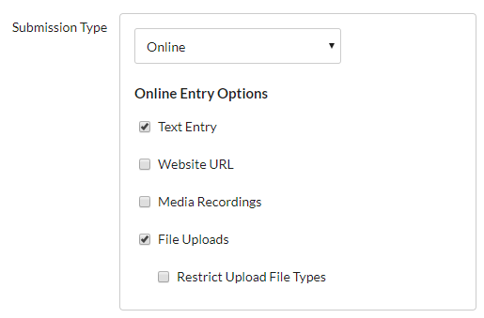
- Scroll down a little more and under Plagiarism Review select Turnitin.
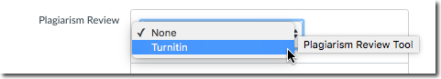
- One you select Turnitin youwill be given the option to change the settings. Go ahead and inspect these but most of the time the default settings will be acceptable. For full details on what these settings do click the Need help link or refer to the Assignment Setup portions of the Turnitin Instructor Guides
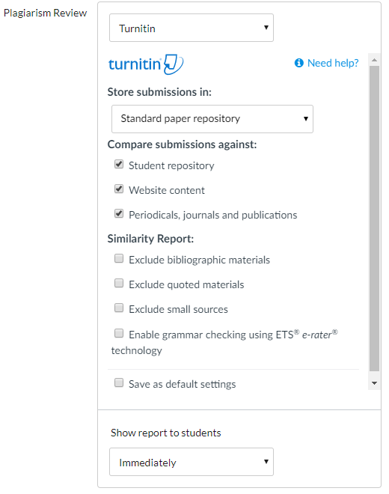
Next select Save or Save & Publish. Your Turnitin Assignment is now ready for student submissions.
