Kaltura Capture

Record your Desktop, Face, & Voice
- Log into Kaltura MyMedia. Click Add New then Kaltura Capture.
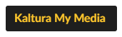
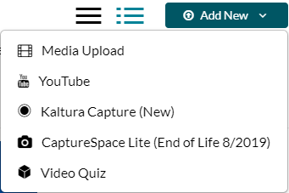
- You will need to click the appropriate Download for your operating system whether it is a Windows computer or a Mac computer
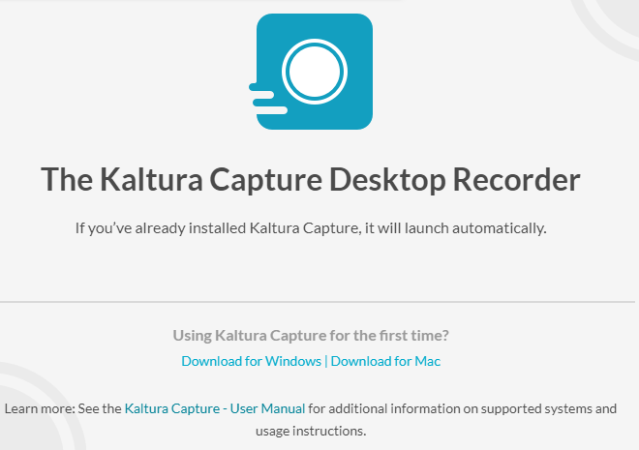
- Once the download is finished and you have run the program you can open Kaltura Capture by using the desktop icon or refreshing the download page and clicking Open Kaltura Capture from the pop up at the top of the screen.
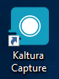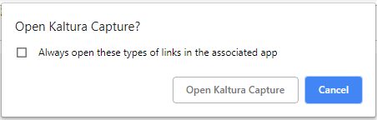
- A Control Panel will pop up with all of the tools you can use for Capturing your desktop
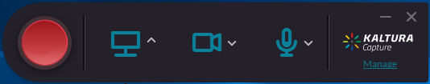
- Clicking the arrow next to any icon will allow you to choose from any option the computer can detect. For example, clicking the arrow next to the screen icon would let you choose which desktop you would like to record from (in the case where you have multiple monitors).
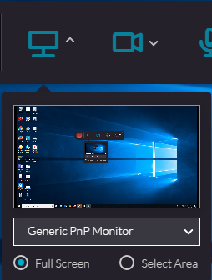
- If you do not want the full screen you can also choose Select Area where a new window will pop up. The size of this area is manipulatable by either choosing a custom size by grabbing the corners and dragging the square to the desired form or choosing one of the presized options from the dropdown.
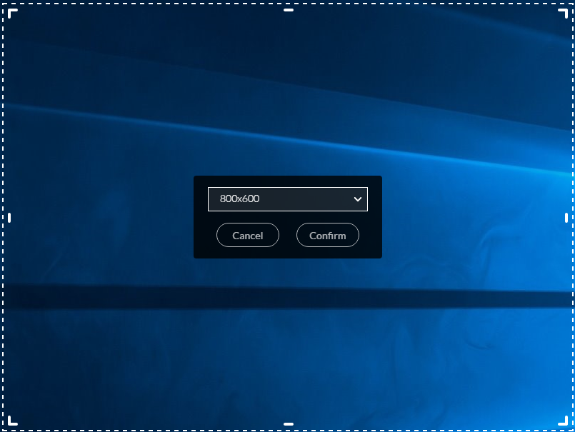
Note: you can record multiple monitors should you wish, though this will cut off the webcam option.
- Clicking the arrow next to the webcam option will allow you to see what you look like prior to recording and give you a chance to see what is in frame. You can also click on the drop down box to see what webcams your computer can detect (Logitec Webcam Pro 9000 in the example below) and switch at this time.
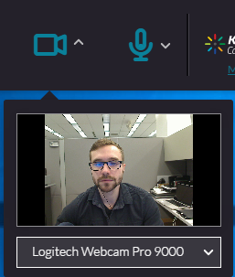
Note: You will not be able to see the webcam footage while recording unless you have no screen recording.
- Clicking the microphone arrow will allow you to switch between microphones that the computer can detect (Line (Dell AC511 USB Sound in the example below)
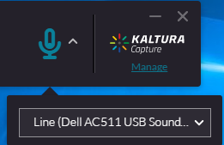
- All of the features mentioned can be toggled on/off as desired prior to recording. So if you just want the screen and voice recorded just click on the webcam to turn it off turning the icon grey with a line through it.
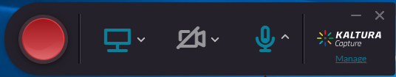
- When your are prepared to record click the large Red button which will prompt a 3-2-1 countdown timer to appear.
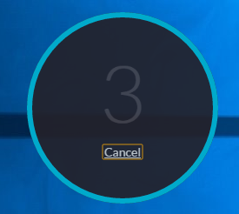
- Some computers may move a bit slower than others so you will not actually start recording until the timer in the bottom right of your screen starts to count up.
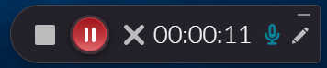
- Pause: Should you need to take a quick break you can click the pause button to temoprarily pause the recording, clicking it again will resume.
Stop: When you are finished recording you can click the stop icon. This will show a prompt asking if you are sure.
Cancel: clicking the X icon will cancel everything you have recorded so far and delete all progress on the current recording.
Microphone: Clicking the microphone icon will mute your voice. The recording will continue without sound until you click on the microphone icon again.
- The Pencil icon will give you a handful of drawing options to choose from
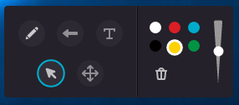
Draw tool: 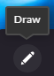 Allows you to freehand draw shapes or designs
Arrow Tool: 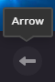 creates an arrow that you can drag to point towards specific things you may be talking about during your recording
Text Tool: Allows you to type text onto the screen
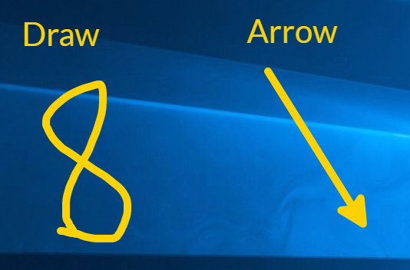
Select Tool: 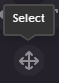 Allows you to select and drag anything created by the previous three tools to a different location.
Cursor Tool: allows you to regain use of your mouse to interact with your computer.
Color, Line Weight, Delete: Here you can change colors, the thickness of your line weights, or delete everything created by the Draw, Arrow, or Text tool
- When you are finished with your recording click the stop icon then confirm.
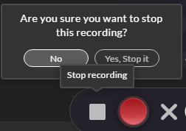
- After stopping you will be brought to the Entry Page.
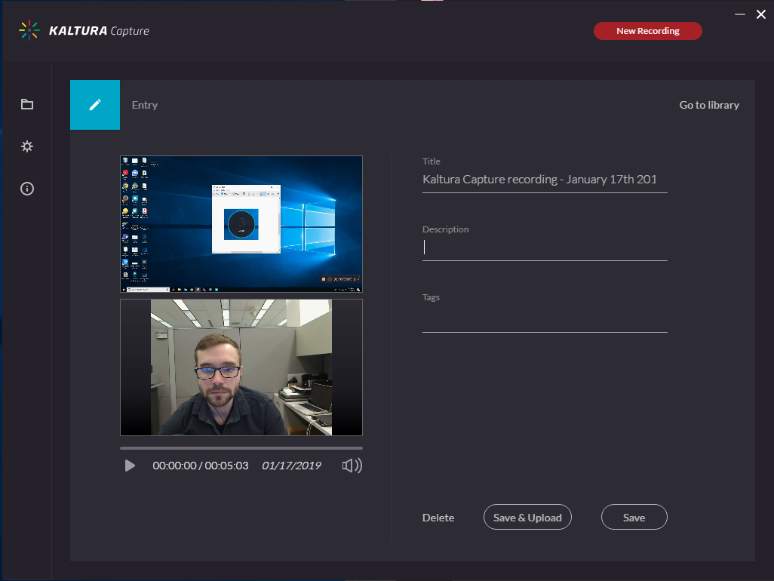
Here you can preview the video to ensure everything is how you want.
- It is important that you edit the Title, Description, & add Tags.
Title: It auto-fills with the date and time of the recording but be sure to add in a specific title that will help you find this recording later. Covering the similar topics over multiple recordings may cause confusion down the line but it is good to keep it as succinct as possible.
Description: This is an added layer of distinction and allows you to express more detail about the contents of the video for future clarification
Tags: These add assistance for finding the video using the search bar. Normally when using the search bar it looks for words in the title of the video as well as any tags with the same keywords. Good examples would be the topic, course ID (ex. BIO-101), or even your username.
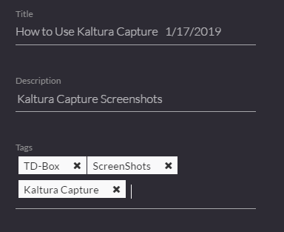
- Once you have reviewed the video and added any tags needed you can then choose:
Delete: If you found that something is seriously wrong with the footage that isn’t fixable in the Kaltura Editor (ex. microphone was on mute or didn’t pick up sound) you can delete it here.
Save & Upload: If everything is ready to be put onto your Kaltura account click this when finished.
Save: If you didn’t have time to review the footage but don’t think it is ready to upload you can save it on your computer until you are ready to upload later.
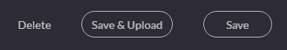
- After you click Save & Upload you will be brought to the Library where the recordings you made on this computer are listed. Your recording will start as pending then quickly turn into a progress bar showing you the percentage it is towards completion. Depending on the length of the video this can take some time.
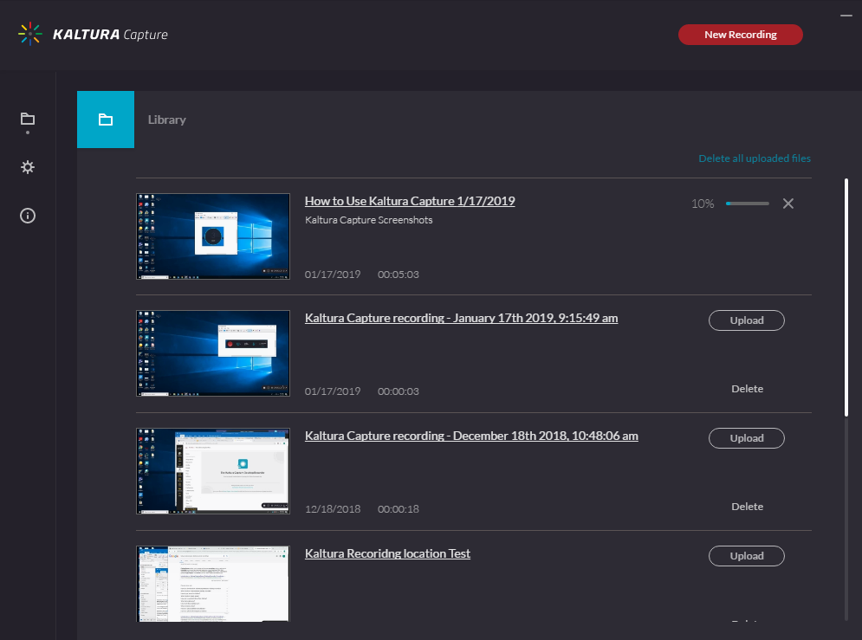
Once your video finishes it will look like this:
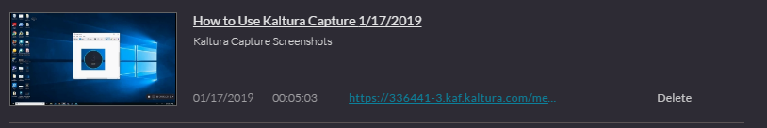
- If you chose Save in step 17 your video will look like this:
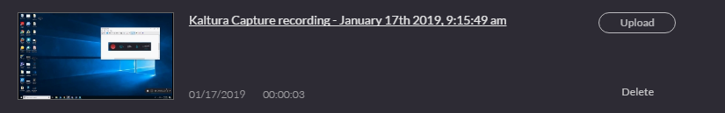
Where you can click on the video title to review and add tags, or click the upload button to complete the process.
- Once uploaded you can go back to your Canvas course and access your Kaltura MyMedia page. Your video should be accessible from here but if you just uploaded it and the recording is rather long you may need to wait some time for it to process. If it has been at least 24 hours since you uploaded and it still will not let you access it you can contact Travis Downing at CITE at x7946.
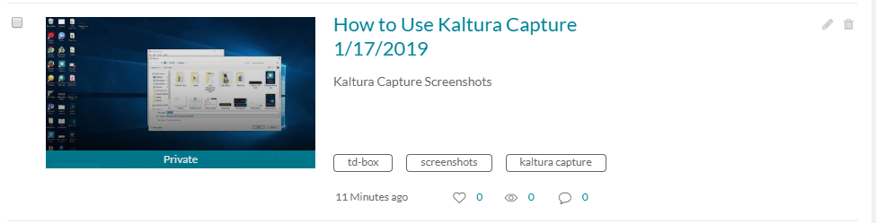
- If you want to access the Library area on Kaltura Capture without making a recording you will need to click Manage in the bottom right on the Kaltura Capture control bar.
- From here you can click on different icons on the left to access other options.
- Settings: In this area adjust camera and screen quality as well as other features. Note this will increase the size of the file and can extend upload times even for shorter videos.
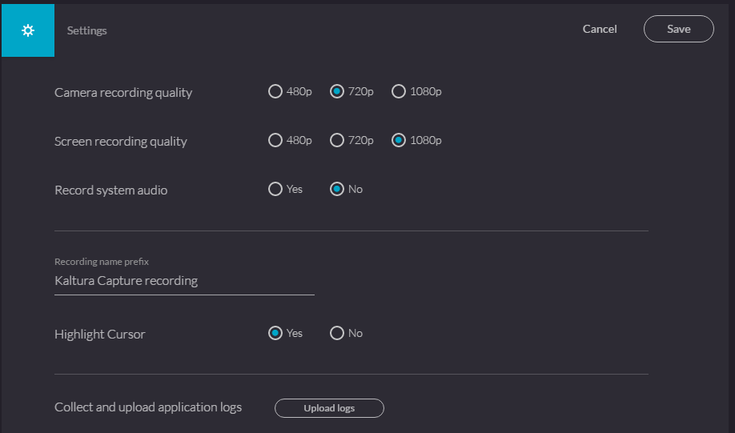
- The Information tab can let you know which version of Kaltura capture you are using and which profile you are signed in as. Note that all recordings made will go to the Kaltura account of whomever is signed in. To change the owner please send an email to Travis Downing at downingt1@nku.edu with the video title, the username of the intended owner, and the username of who currently possesses the video.
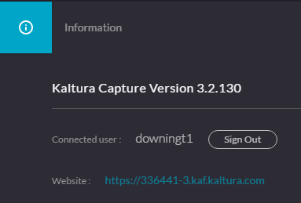
- If you want to go back to the recording control panel just click the red New Recording button in the upper right hand corner.

