Student use – Submitting a video from Kaltura
You can embed your Kaltura video wherever there is a text box in Canvas. The below instructions are focused for submitting to an assignment but could just as easily be used for a discussion board post.

1. When submitting your assignment choose the Text Entry tab.
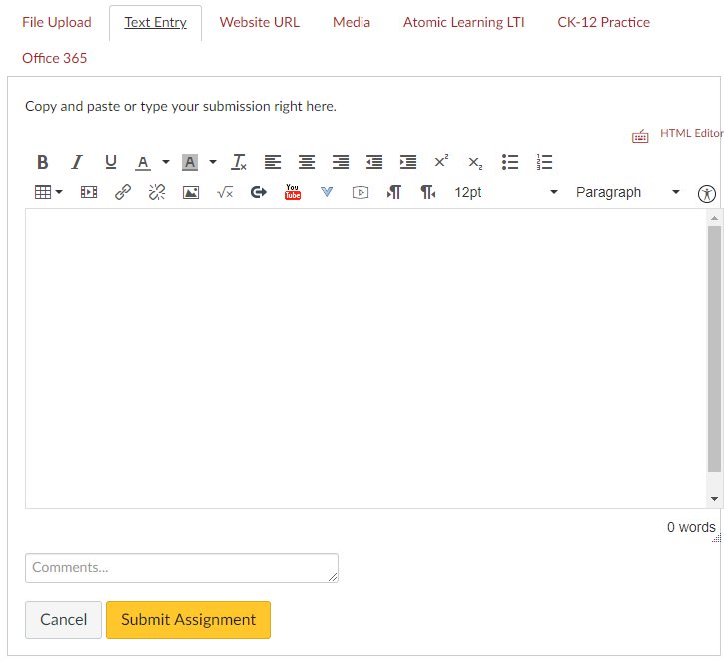

2. In the second row of tools there is a blue arrow next to the YouTube icon. Once you click the blue arrow the Embed Kaltura Media tool should appear, select it.
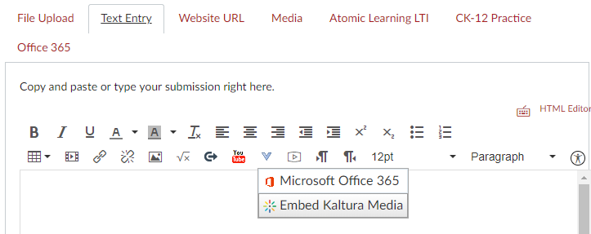

4. A list of videos under your account should appear, hit the Select button to the right of the one you wish to use.
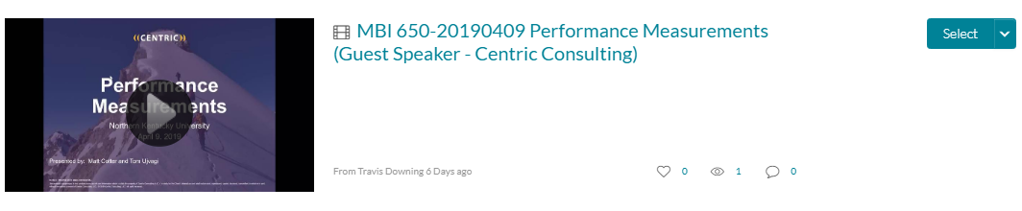

5. If your recording is still on your device and hasn’t been uploaded to Kaltura yet you can click +Add New in the upper right of this page and then select Media Upload.
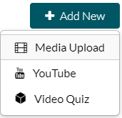

6. You should see your video now in the initial text bot, hit Submit Assignment.
