# Course Title Section, time, location, etc.

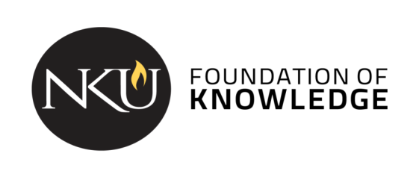

# Course description:**[**insert catalog description]

**NKU’s General Education Program** is a shared Norse experience that guides students in becoming independent learners, innovative thinkers, and responsible citizens. The program gives students a foundation of values and knowledge and aligns with career-focused skills. [Instructors: [this link](https://nku.instructure.com/courses/41044/files/8380486) in Canvas has optional / additional information about the Gen Ed program, including a Word Cloud that might be useful for a first day conversation about the purpose of general education.]

#### Student Learning Outcomes

[Course name] is a course that partially fulfills the Cultural Pluralism category.  As part of the general education curriculum, all students in this course will be directly assessed on the following outcomes:

1. Students compare cultures from historical, local, national, or global perspectives. [B1]
2. Students demonstrate how literature, the arts, and/or artifacts reflect and influence culture. [B2]
3. Students demonstrate an understanding of the factors that influence global awareness. [E2]

In addition to the general education program outcomes, the following outcomes will also be addressed:

[Insert course specific outcomes]

*The remainder of the syllabus should adhere to the university’s syllabus template: Gen Ed template with Provost’s information found on* [*Gen Ed webpage*](https://inside.nku.edu/gened/faculty/syllabus-templates-by-category.html)*.*