**Course Title**  
**Section, time, location, etc.**

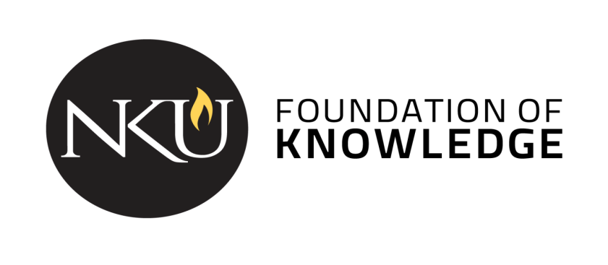

**Course description**: [insert catalog description]

**NKU’s General Education Program** is a shared Norse experience that guides students in becoming independent learners, innovative thinkers, and responsible citizens. The program gives students a foundation of values and knowledge and aligns with career-focused skills. [Instructors: [this link](https://nku.instructure.com/courses/41044/files/8380486) in Canvas has optional / additional information about the Gen Ed program, including a Word Cloud that might be useful for a first day conversation about the purpose of general education.]

# Student Learning Outcomes [Instructors should select which set of three is appropriate to your Global Viewpoints course and only include those on the syllabus.]

[Course name] is a course that partially fulfills the Global Viewpoints category. As part of the general education curriculum, all students in this course will be directly assessed on the following outcomes:

1. Students compare cultures from historical, local, national, or global perspectives. [B1]
2. Students demonstrate how literature, the arts, and/or artifacts reflect and influence culture. [B2]
3. Students demonstrate awareness of global issues. [E1]

OR

1. Students demonstrate awareness of global issues. [E1]
2. Students demonstrate an understanding of the factors that influence global issues. [E2]
3. Students explain how personal choices impact the world.[E3]

In addition to the general education program outcomes, the following outcomes will also be addressed:

[Insert course specific outcomes]

*The remainder of the syllabus should adhere to the Provost’s Syllabus which can be found on the* [*Gen Ed webpage*](https://inside.nku.edu/gened/faculty/syllabus-templates-by-category.html)*.*