**Course Title**  
**Section, time, location, etc.**

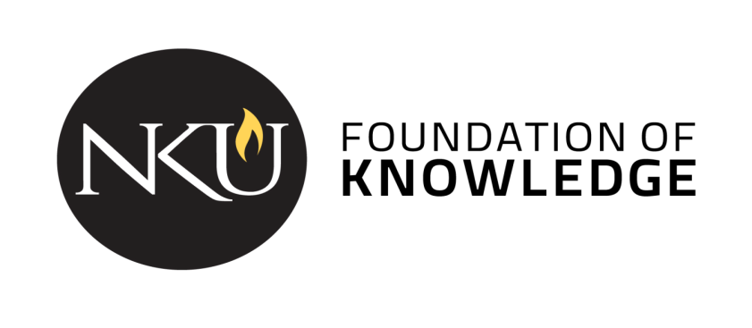

**Course description**: [insert catalog description]

**NKU’s General Education Program** is a shared Norse experience that guides students in becoming independent learners, innovative thinkers, and responsible citizens. The program gives students a foundation of values and knowledge and aligns with career-focused skills. [Instructors: [this link](https://nku.instructure.com/courses/41044/files/8380486) in Canvas has optional / additional information about the Gen Ed program, including a Word Cloud that might be useful for a first day conversation about the purpose of general education.]

**Student Learning Outcomes**

[Course name] is a course that partially fulfills the Written Communication category. As part of the general education curriculum, all students in this course will be directly assessed on the following outcomes:

1. Students consider context, audience, and purpose as appropriate with assigned tasks. [C1]
2. Students use appropriate and relevant content to communicate ideas. [C2]
3. Students create and write coherent grammatical pieces. [C3 W]

In addition to the general education program outcomes, the following outcomes will also be addressed:

[Insert course specific outcomes]

*The remainder of the syllabus should adhere to the Provost’s Syllabus which can be found on the* [*Gen Ed webpage*](https://inside.nku.edu/gened/faculty/syllabus-templates-by-category.html)*.*