NKU students expand Beverly Hills display at museum
Posted by ajoering 01/27/11, 2:30 pm
By Amanda Joering Alley • ajoering@nky.com
Part of the Fort Thomas Military and Community Museum is getting a face-lift and expansion thanks to a project being completed by Northern Kentucky University students.
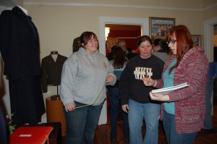
Northern Kentucky University students Jessica Runyon, Tiffany Best and Gretchen Gauldin take measurements as part of a class project at the Fort Thomas Military and Community Museum. Amanda Joering Alley/staff.
Through a partnership with the Public History Master’s degree program at NKU, the museum is bringing in a class to improve and expand the Beverly Hills Supper Club display during the next several months.
“This partnership is just the best thing,” said Debbie Buckley, the Fort Thomas renaissance manager. “We profit because these classes do projects for us, and they profit because they get to do some hands-on learning.”
The project, being completed by Dr. Brian Hackett’s class of 24 students, will be expanding the display to include another entire room and breaking the display down into three sections, one about the grandeur of the supper club, one about the fire and one about the aftermath of the fire and how it changed fire codes nationally.
Hackett said the class, which has formed several committees to cover various parts of the project, will be building a model of the display, coming up with designs and creating the finished product.
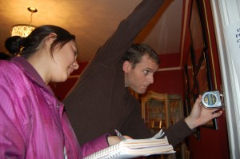
Justine Yohe and Steven Whaley measure a wall of the museum. Amanda Joering Alley/staff.
“This is a chance for these students to work on a display from the concept to the completion,” Hackett said.
Hackett said it is hard not to focus just on the fire since that is at the forefront of most people’s minds when thinking of the supper club, but the class will be working hard to show what made this club important before the tragedy, from the famous musicians who played there to the special events like weddings that took place.
Student Jodie McFarland said being able to do a project like this is just one of many things that makes the master’s program at NKU so great.
“Projects like this add value to the community and allow us to get experience and make partnerships, which is invaluable stuff,” McFarland said.
Along with Beverly Hills project, the museum is also undergoing building renovations, planning fundraisers for later this year and preparing for several displays, including the work of local artist Greg Manchess May through August.
In December, the museum will be hosting the Smithsonian’s traveling exhibit “Journey Stories.”

