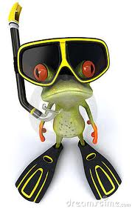

Safari to the Water Underworld

## July 12-13, 2017

## 9:00-2:30 am

Discover the fascinating world of plant and animal life lurking beneath the water in ponds and rivers. Use various sampling devices to collect critters and examine them up close using microscopes. Use equipment professionals use to monitor the water quality to see how healthy the water is for plant and animal life. Make a fish print and learn how to fish. Two exciting days of water exploration. Sign Up today!

Name: Grade: (Fall’14)

Parent's name:

Home phone: Cell Phone:

Address:

City: Zip Code:

Email:

Alternative Contact Name:

Relationship to child:

Home phone: Cell Phone:

Email:

**Greenacres Foundation**

[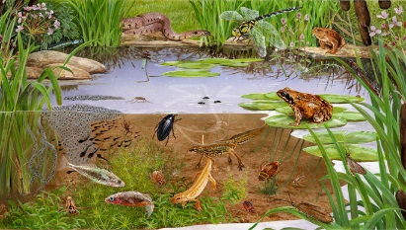](http://www.google.com/url?sa=i&rct=j&q=&esrc=s&frm=1&source=images&cd=&cad=rja&docid=aDNLMOV2l4NQ9M&tbnid=x0Ck7SdfPB157M:&ved=0CAUQjRw&url=http://www.sjcillustration.com/habitats_pond.html&ei=cBr0UpCqGeLiyAHBg4HIBw&bvm=bv.60983673,d.aWc&psig=AFQjCNF9xpVf1LatyQ4B_epkC8smP97TjA&ust=1391815570170502)**Water Quality Project LLC**

Your child ______________________________ is registered for

***Safari to the Water Underworld*** July 12-13, 2017, 9:00 - 2:30 am.

We look forward to seeing you this summer!! 7/12/17 Drop-off at the Greenacres River Education Center, 6040 Price Road, Milford, OH, OH 45150; 7/13/15 Drop-off at Greenacres Pond Site, 8495 Spooky Hollow Road, Cincinnati, OH 45242. Office phone: (513) 371-5474. Day of program (513) 900-7648.

Sincerely,

Greenacres Staff