Student Conduct Process
If you receive a letter asking you to set a meeting with a NKU staff member about a student conduct issue, this is what you can expect:

Initial Meeting
Check your NKU email and schedule a meeting with the assigned staff member.
If you don't, we won't get to hear your side of the situation.

STEP

01

Information
STEP We will remind you of,
02
and navigate through, NKU Community Standards & Student Rights with you.

Investigation
We will ask you questions about your involvement in, and knowledge about, the reported incident

STEP

03

STEP

04

Resolution
You can resolve most cases in your initial meeting, or choose to have an Administrative/University Conduct Board hearing.

Moving Forward
You should complete any sanctions by the deadlines established. You may appeal Administrative/University Conduct Board decisions.

STEP

05

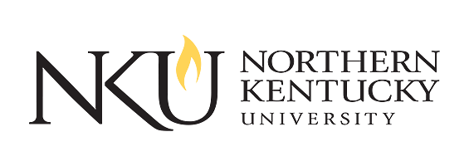

scra. nku. edu Student Union 301

