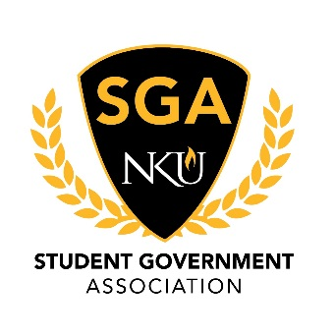

Minutes

November 16, 2020

1. Call to Order
   1. President Goodwin called the meeting to order at 3:31 pm
2. Roll Call
   1. Justices Present:
   2. Justices Absent: Garcia, Price
   3. Justices Excused:
   4. Senators Present: Abraham, Ampfer, Arango, Cantero, Carter, Coates, Delgado, Goebel, Goodwin, McCubbin, Meador, Miller, Minniefield, Nguyen, Potter, Renton, Sullivan, Stevenson, Turner, Uhlenbrock, Weis
   5. Senators Absent:
   6. Senators Excused: Hall, Sis
   7. Executive Cabinet Present: Cleary, Cordle, Derks, Goodwin, Miller, Millward, Wilson
   8. Executive Cabinet Absent:
   9. Executive Cabinet Excused:
3. Pledge of Allegiance
4. Reading of Minutes
   1. President Goodwin entertained a motion to approve the minutes as distributed. Senator Renton sub-moved and Senator Abraham seconded. The motion carried and minutes were approved as distributed.
5. Open Session
   1. Chairman Nguyen presented the 2020 Campus Safety Walk report.
   2. Andy Meeks gave updates on food and beverage services, parking services, Thanksgiving break plans, and winter break plans.
   3. Director of Norse Advising, Frank Robinson gave updates on advising initiatives that benefit students
6. Executive Board Reports
   1. Secretary of Public Relations, Emily Miller
      1. No report
   2. Secretary of Student Involvement, Allan Millward
      1. No report
   3. Secretary of Administration, Stephen Cordle
      1. No report
   4. Vice President, Mia Derks
      1. Book grant closes at 5:30 tonight!
      2. End of report
   5. President, Lauren Goodwin
      1. Update from Board of Regents meeting
      2. End of report
7. Committee Reports
   1. Student Advocacy, Ronald Delgado
      1. NVP Townhall November 30th
      2. End of report
   2. University Improvements, Hanson Nguyen
      1. No report
   3. Academic Excellence, Hannah Miller
      1. No report
8. Ex Officio Reports
   1. Chief of Staff, Jacob Wilson
      1. No report
   2. Chief Justice, TJ Cleary
      1. The Judicial Council is working on election commission
      2. End of report
9. Advisor Reports
   1. Sarah Aikman
      1. Puppy of the day. Yay!
      2. End of report
   2. Arnie Slaughter
      1. Next Monday Dr. Anita Vaidya will be our guest
10. Liaison Reports
    1. The Northerner
       1. No report
    2. Staff Congress
       1. No report
    3. RHA
11. Old Business
    1. No Business
12. New Business
    1. No Business
13. Announcements
    1. President Goodwin reminded everyone the NKU to You event is tonight. Get pumped!!!
14. Adjournment
    1. President Goodwin accepted a motion to adjourn from Senator Abraham. The motion was seconded by Senator Carter. The motion carried and meeting adjourned at 4:31 pm.