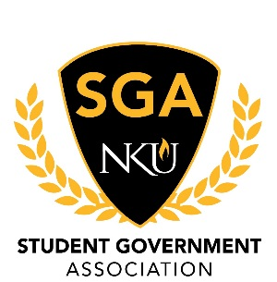
Minutes
January 25, 2021
- Call to Order
  - President Goodwin called the meeting to order at 3:30 pm
- Roll Call
  - Justices Present: Price
  - Justices Absent: None
  - Justices Excused: Garcia
  - Senators Present: Abraham, Ampfer, Arango, Cantero, Coates, Delgado, Goebel, Goodwin, Miller, Minniefield, Nguyen, Renton, Sis, Stevenson, Turner, Uhlenbrock, Weis
  - Senators Absent: Hall, Potter, Sullivan
  - Senators Excused: Carter
  - Executive Cabinet Present: Cleary, Cordle, Derks, Goodwin, Miller, Millward
  - Executive Cabinet Absent: Wilson
  - Executive Cabinet Excused: None
- Pledge of Allegiance
- Reading of Minutes
  - Chairman Delgado motioned to approve the minutes as electronically distributed. The motion was seconded by Chairwoman Miller. The motioned carried and minutes were approved.
- Open Session
  - No business
- Executive Board Reports
  - Secretary of Public Relations, Emily Miller
    - Congratulations to Chairman Nguyen for being in the homecoming top 10
    - Office hours
    - End of report
  - Secretary of Student Involvement, Allan Millward
    - Office hours
    - End of report
  - Secretary of Administration, Stephen Cordle
    - Office hours
    - Appointment update
    - End of report
  - Vice President, Mia Derks
    - Report from Mental Health Advisory Board
    - Report from Faculty Senate
    - Office hours
    - End of report
  - President, Lauren Goodwin
    - Office hours
    - Please reach out to e-board members via email this semester.
    - There will be a competition for the general body member who attends the most SGA sponsored events
    - End of report
- Committee Reports
  - Student Advocacy, Ronald Delgado
    - Office hours
    - End of report
  - University Improvements, Hanson Nguyen
    - Update from committee
    - End of report
  - Academic Excellence, Hannah Miller
    - Victor Talk update
    - Office hours
    - End of report
- Ex Officio Reports
  - Chief of Staff, Jacob Wilson
  - Chief Justice, TJ Cleary
    - Election updates are forthcoming
    - Office hours
    - End of report
- Advisor Reports
  - Sarah Aikman
    - No report
  - Arnie Slaughter
    - No report
- Liaison Reports
  - The Northerner
    - No report
  - Staff Congress
  - RHA
- Old Business
  - No business
- New Business
  - Committee breakouts and committee report outs
- Announcements
  - Vice President Derks spoke about applying for CARES funding
- Adjournment
  - Chairman Delgado motioned to adjourn. Chairwoman Miller seconded and the motion carried. Meeting adjourned at 4:33 pm.

