2021

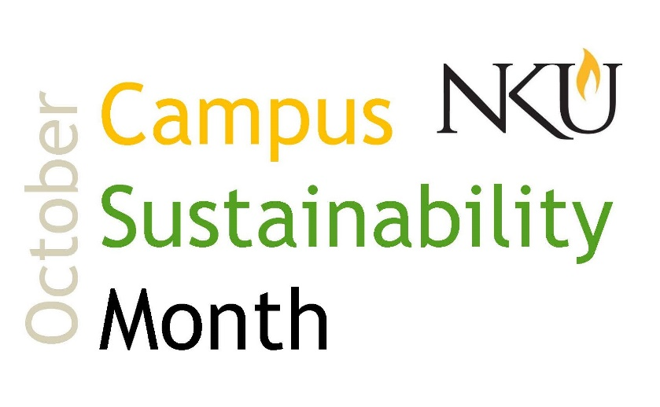
Schedule of Events
October 1- World Vegetarian Day, 11am-1pm, Free, In-Person
Visit us in the lobby of the Student Union to learn about the benefits of vegetarianism and where you can find vegetarian food on campus! From 11am - 1pm, meet our Student Sustainability Changemaker and gather information on how you can eat more sustainably.
October 5- Farm Share Presentation, noon, Free, Virtual
The Organic Association of Kentucky will present about KY Farm share Coalition, a community shared agriculture (CSA) program. Community Supported Agriculture (CSA) is a subscription-based model of buying food directly from a local farm. Members sign up in advance of the season and then receive a weekly share of the farm's harvest May through October.
Register in advance for this event. After registering, you will receive a confirmation email containing information about joining the event.
A zoom account is required to attend this event. Create one free on their website.
October 6, Energy Efficiency Day, Free
Energy Efficiency Day is the nationally celebrated Energy Efficiency Day! NKU is a participant and you can be, too! Find tips on how to save energy at work and at home. #EEDay2021
October 7, Sustainability Tabling Event, 11am-1pm, Free, In-Person
Come visit us in the lobby of the Student Union to drop off batteries and ink cartridges. You can also meet our Student Sustainability Changemaker and learn out to get involved in NKU's Office of Sustainability.
October 9, REFS Volunteer Day: A Bridge Through Nature, 8:30am-5pm, Free, In-Person
Join faculty, staff, and students at NKU's Research and Education Field Station to build a bridge on wetland trails. See REFS website for details.
"The St. Anne Wetlands trail is actively used by a broad spectrum of the public for hiking, bird watching, nature escapes, trail running, dog walking, nature walks, and environmental education...This boardwalk will solve the problem on the northwest trail loop that is very muddy or partially under shallow water during the spring or very wet periods."

October 12- 14, AASHE Global Conference on Sustainability in Higher Education, Virtual
"With a theme of “The future is…”, this year’s Global Conference on Sustainability in Higher Education reflects the uncertainty about the future that many feel and invites participants to recommit themselves to the urgent work of building a future that is sustainable, equitable, and resilient. We seek to highlight inspiring examples of higher education leadership that empower participants to envision and create such a future. Ultimately, the future is ours to make."
Register for this virtual event with your NKU email to recieve our institution membership rate, which is available to all students, faculty, and staff.
October 14, Electrada Presentation & EV Car Demo, 3-5pm, Free, In-Person
Join us in Lot F (behind the new residence hall) for a presentation by Electrada. NKU recently partnered with Electrada, a Cincinnati-based company, to scale electric vehicle charging stations across campus. Electrada will share information about their company and speak about the new charging stations located in Lot F. There will also be electric vehicles on display, compliments of Drive Electric Cincinnati, that participants can tour and sit in. This will be an outdoor, in-person event. (Rain date will be October 21, 3-5 pm.)
October 16, Tour the Cincinnati Recycling and Reuse Hub, 11am, Free, In-person, Open to all
Location: 911 Evans St., Cincinnati, OH
Join us at Cincinnati Recycling and Reuse Hub for a tour of their operations. The CRRH collects items that are not permitted in standard recycling (pens, straws, plastic clamshells, cd's, styrofoam, batteries, and lots more) and sends them off to be properly recycled. The amount of items they collect is extensive and we encourage you to come see their impressive operations during our free tour.
The CRRH is located in a large, open space warehouse in Cincinnati and masks will be required. This event is open to all.
October 16, World Food Day, Virtual
The way we eat can have a significant impact on the planet, from carbon emissions to crop monocultures to seasonal choices.
"As a global community, we each have a role to play in the transformation of agri-food systems - from governments to private companies, farmers, civil society, academia, and all individuals, including youth! Together we can empower each and every element of our agri-food systems to collaborate more fairly, sustainably and inclusively from farm to table, and beyond." Learn about how you can take action with the Food and Agriculture Organization of the United Nations on World Food Day.
October 18, Recycling Presentation with Rumpke, 12-1 pm, Free, Open to all, Virtual (Zoom).
Confused about what can and cannot be recycled? Join us for this recycling presentation and help clear up the confusion! Anne Gray from Rumpke will present about their local facility in Cincinnati and educate attendees on how to properly recycle.
We recommend watching "The Story of Rumpke" video before attending this event.
Register in advance for this event. After registering, you will receive a confirmation email containing information about joining the event.
A zoom account is required to attend this event. Create one free on their website.

October 18 - 25, Global Climate Change Week, Virtual
Global Climate Change Week aims to encourage academic communities – academics, students, and professional staff at universities – in all disciplines and countries to engage with each other, their communities, and policy makers on climate change action and solutions. Learn how to organize an event at the university level during Global Climate Change week.
October 26, Sustainability Tabling and Collection Event, 11am-1pm, Free, In-Person
Come visit us in the lobby of the Student Union to drop off batteries and ink cartridges. You can also meet our Student Sustainability Changemaker and learn out to get involved in NKU's Office of Sustainability.
October 26, Mason Jar Hydroponics, noon- 1pm, SU 108, Free, In-person
See our website for more details.

