Northern Kentucky University

Assessment Guidebook

Fall 2023

Contents
Introduction 3
Institutional Effectiveness and Assessment at NKU 3
Assessment Tools and Support 5
The Assessment cycle at NKU 6
- Phase I- Planning stage 7
- Phase II- Assess stage 10
- Analysis Stage 12
Grades and Assessment measures 12
- Improve with action plans 13
Assessment Schedule 14

Introduction
This guidebook is designed to provide guidance and direction for Assessment at Northern Kentucky University (NKU). More specifically, it aims to assist the campus community in developing assessment plans, articulating objectives and outcomes, using appropriate methods and measures of assessment, along with analyzing and using assessment results for performance enhancement. This guidebook serves as one of the many ways NKU tries to live its mission, which states that:
“As a public comprehensive university located in a major metropolitan area, Northern Kentucky University delivers innovative, student-centered education and engages in impactful scholarly and creative endeavors, all of which empower our graduates to have fulfilling careers and meaningful lives, while contributing to the economic, civic, and social vitality of the region”.

Assessment at NKU
Assessment at NKU is defined as a process by which information is gathered on university operations and student learning to be evaluated for the purpose of improvement of student experiences and improved operational efficiencies. At NKU, assessment is viewed as an inquiry process that supports the university’s commitment to institutional effectiveness and excellence in student learning and teaching. Assessment could also be viewed as an advocacy process. Assessment allows areas (e.g., degree programs, administrative areas, etc.) to show their effectiveness and demonstrate how additional resources could be used to expand capacity based on actual outcomes. Assessment at NKU is identified through six guiding principles:

- Integrated: Rather than view assessment as an isolated task or a series of hoops, assessment at NKU is an organic and integrated process aiming to yield real insights into student learning, and whether we have achieved success in meeting student learning outcomes, and improving their educational experiences.
- Collaborative: Assessment at NKU is not a one person job but rather a process that aims to promote dialogue and conversations among appropriate constituents (e.g., faculty members, administrative units’ personnel etc.) in order to sustain a shared culture of continuous improvement and to better serve the students.
- Valuable: Assessment is something we owe ourselves and our students; it enables us to understand that we are not just “spinning our wheels.” What we learn about our courses, our programs, and our operations can be significant, and that knowledge can impact and contribute to student success.
- Ongoing and Coherent: Assessment does not stop but continues to build upon itself and the knowledge obtained. It employs consistent methods and reporting techniques across semesters and years to reduce variables and ensure transparency.
- A Path to Improvement: Only through comprehensive and reflective assessment can we make sure we are providing our students with the best experiences. Assessment not only also supports NKU quality control efforts but is also an integral part of program accreditation and reviews.

- A Hallmark of a Strong University: A continuing and comprehensive assessment allows decision-making about educational programs/units to be data-informed and defendable. Assessment provides critical information for ensuring programs and services are meeting the needs of our students and the community.

Institutional Effectiveness and Assessment at NKU
As a publicly funded institution, NKU has an obligation to be transparent and accountable in the experience it provides it students and in the way it runs its operations. One of the roles of the regional accreditation agencies (e.g., SACSCOC) is to evaluate the extent that institutions like NKU are examining their performance in these areas and responding to their findings. Institutional Effectiveness is the systematic and ongoing process of collecting, analyzing, and acting on data and information relating to the goals and outcomes developed to support NKU’s mission and purpose. Assessment is an integral part of Institutional Effectiveness at NKU. It provides evidence for the strategic planning efforts and efficiencies, as reflected in figure 1. Three groups have led the data collection, analysis, reporting, and facilitation of the overall process of institutional effectiveness on this campus.
The Office of Planning and Performance has three large areas of focus: strategic planning, unit assessment planning, and institutional performance reporting or benchmarking around NKU's progress and achievements. This office supports institutional effectiveness around the overall strategic plan and in the non-academic areas of the institution. The Office of Institutional Research collects, analyzes, and reports information in support of NKU’s mission. The Office of Institutional Research provides information to internal and external constituents and serves as a source of official information about the university. These two areas are under one executive director and are collectively called Planning and Institutional Research (PIR). The third group is the Office of Undergraduate Academic Affairs (UGAA).
UGAA provides leadership on issues related to curriculum, assessment, and student success initiatives. Additionally, UGAA collaborates with the undergraduate community to plan and implement programs that enhance the academic life of students and lead to student success.
Figure 1 shows the integration of the institutional effectiveness activities across the campus and the ways in which PIR and UGAA work collaboratively to help facilitate and coordinate these efforts. Figure 1 shows the three levels (i.e., grey boxes) of institutional effectiveness across the NKU campus and the office that is primarily responsible for supporting that work. The next level of figure 1 (i.e., beige boxes) shows the institutional units that do reporting at each level. The final level of figure 1 (i.e., green boxes) shows the type of reporting that is done by each unit and the reporting tool that is utilized.
NKU monitors overall institutional performance relative to its institutional mission via a series of metrics connected to the strategic plan. These metrics serve as an approximation and an indirect measure of NKU’s fulfillment of its mission, goals, and strategic objectives. These metrics are used in concert with analyses of data on historical trends, current environments, and expected future situations to identify targets for measuring institutional performance. In order to engage the campus and promote transparency, NKU shares its metrics, targets, and progress on the public-facing Success By Design: Progress webpage. Also, NKU provides access to historical Student Data in the form of public-facing, interactive dashboards.

The next level of institutional linkage between planning, assessment, and continuous improvement is comprised of the major institutional units, including individual colleges, the divisions outside of academic affairs, and larger individual business units of the institution, such as Human Resources,

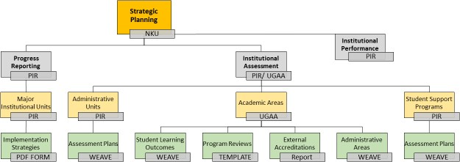
Information Technology, and Planning and Institutional Research. Progress reports on recommendations from strategic initiatives implementation teams are collected at this level.

Figure 1: Institutional Effectiveness and Assessment at NKU
The third level of institutional effectiveness occurs through planning, assessment, and continuous improvement efforts within individual units, departments, student-facing programs, and degree programs. This work includes processes such as campus-wide alignment planning, academic program review and/or accreditation, along with programmatic assessment plans for student learning outcomes

Assessment Tools and Support
Campus wide assessment at NKU is housed in the Weave platform. All units on campus keep their assessment plans in Weave. Support for Weave is organized along divisional lines with a campus wide Weave support group that includes members from Academic Affairs and Planning and Institutional Research. Figure 2 shows the different user types and the types of activities they perform in Weave.
Figure 2 identifies the two types of plans that are in Weave for the Division of Academic Affairs. There are plans related to the academic programs and plans related to the administrative units. The left side of figure 2 identifies these plans and also identifies who the primary users of Weave are for these plans. All assessment planning done in Weave within the Division of Academic Affairs is supported by the Office of Undergraduate Academic Affairs.
Figure 2 also highlights the assessment work done outside of academic affairs. The right side of figure 2 shows the assessment work being done by student support units and other administrative units across campus. These units are support by Planning and Institutional Research (PIR).

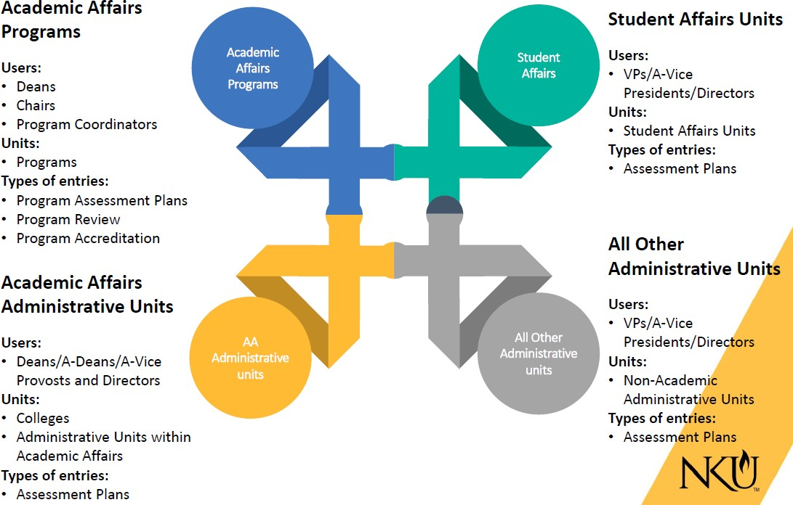

Figure 2: Organization of Weave Support at NKU.

The Assessment Cycle at NKU
Assessment at NKU follows a cycle of 4 mains stages. Processes and activities included in each one of these phases are detailed in the following pages.
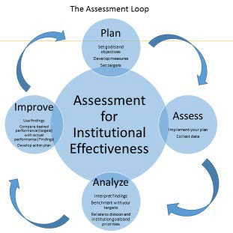

Phase I- Planning stage
At this stage units/programs:
  - Articulate learning outcomes/objectives based on mission and goals
  - Define measures
  - Establish targets
  - Suggest a timeline for implementation
In the planning phase educational programs typically identify the competencies, skills and knowledge they expect students to achieve as a result of completing the program. Similarly, administrative units also define specific objectives that they hope their units will achieve by a given time period. Objectives can be thought of as the question you are trying to answer. Do students develop appropriate levels of disciplinary knowledge as they matriculate through the degree program? Does this office have sufficient levels of customer satisfaction? Next, you would then consider the types of evidence that would help you answer your question, along with thresholds for success. See Appendix A for NKU’s definitions of Goals, objectives, measures, targets and implementation.
Learning outcomes/objectives must be specific enough to allow the collection of evidence in order to make a judgement about the extent to which the objectives/learning outcomes have been achieved. Here are examples of appropriate and poor SLOs/objectives:

Appropriate:
    - SLO: Students will be able to apply design principles in computer applications
    - Objective: Increase students’ awareness of library services and applications
    - Objective: Reduce work order requests completion time by 5%
    - Objective: Increase minority vendor activity in solicitations and as service providers
    - Objective: Develop a safety program that minimizes risks of work related injuries and illness
These examples are specific, only targets one action verb (competency) which is for the SLO to “apply”, something very specific: “design principles in computer applications”. For the objective it is to increase awareness.

Poor:
    - SLO: Students will demonstrate knowledge of design principles, and demonstrate understanding in applying design principles and communicate them effectively.
    - Objective: Enhance student support services’ program
    - Objective: Energy usage is part of the decision making process
    - Objective: Provide inclusiveness training opportunities
It is clear that the ambiguous SLO/objective bundled together many competencies that require different types of assessments. Further it includes many action verbs, most of which are not clear enough. For

example, what does it mean to demonstrate competency, or demonstrate understanding? How will students demonstrate competency? The objective is also too general and does not give indication of what and how to enhance the services. Does it mean more students using the services? Does it mean less wait time? Does it mean making services available online?
The checklist below shows some guiding questions on how to write specific and clear student learning outcomes/objectives. This checklist is to facilitate your work and can be adapted as you see fit for your program. You can also add other criteria if you wish.

Student Learning Outcomes/Objectives | Yes | No | Comments
Does the student learning outcome/objective Identify clear and specific performance?
Does the learning outcome/objective focus on a single performance?
Note: Avoid learning outcomes/objectives that
bundle multiple performance verbs and competencies
Is the expected performance (action verb) at the appropriate level of competency for your course (e.g.,
using Bloom)?
Is the performance measurable/observable? (Is it possible to collect data for the assessment of the learning outcome?)
Does the learning outcome/objective support the overall program/unit goals and mission?

More examples of how to articulate specific learning outcomes or objectives and how to target specific levels of performance can be found in Blooms’ taxonomy.
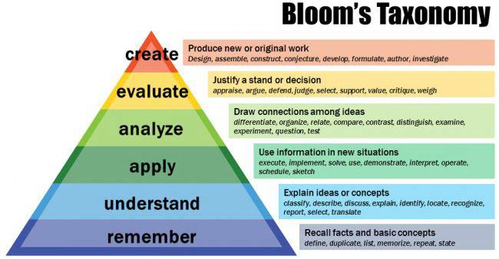

Source: Vanderbilt University Center for Teaching and Learning

The result of this planning phase will be an assessment plan template. The NKU template shown below provides definitions for the different components of the assessment plan. Here is an example of program’s assessment plan. This template can then be used to create the assessment plan in the Weave application.

Assessment Plan

Program: | Department:
College: | Program Director/Coordinator:

Goal | Outcome/Objective | Measure | Target | Implementation
1.
2.
3.

Phase II- Assessment stage
During the assess stage, entities at NKU undertake the following activities:
- Develop assessment measures (rubrics or performance criteria): in this step, degree programs and other units develop or select the means through which students will be asked to demonstrate their performance. A degree program may choose as the measure for a particular SLO a lab report or an exam, while a support unit like Latino Programs and Services could decide that a survey of student engagement might be the best measure.

Assessment measures (methods) can be classified into two categories:
- Direct Assessments: This category includes assessments that look into student learning by evaluating work they have completed. That could a research paper, an exam, a capstone etc. Administrative units can be looking at things like: the number of referrals processed, the number of attendees at a training, student retention, costs, customer satisfaction, or if a project was completed by the due date.

- Indirect Assessments: This category includes assessment that ask students to report their perceptions of what they have learned. Student surveys and or focus groups are in this category. Administrative indirect assessments are based on perceptions of performance or efficiency and includes things like: evaluating teamwork by looking at performance reviews, evaluating impact with Google Analytics via hits on webpages, or measuring impact just through attendance.

Once an assessment measure is selected, entities engaged in assessment need to define assessment or performance criteria. That could be a rubric or other success criteria for administrative units (e.g., number of students engaged in students’ organizations, percentage of increase in extracurricular activities, etc.).

In any case, an assessment measure must match and align with the expected SLO/Objective to provide meaningful results. Examples of measures that align with SLOs/Objectives and others that don’t are provided below:

Aligned:
Examples for degree programs, certificates etc.
- SLO: Students will communicate scientific information effectively through written and oral means.
- Measures: Students’ lab written report and oral presentations

Examples more appropriate for administrative units (admissions, student affairs etc.)
- Objective: Increase study abroad participation by 5%/year
- Measures: Enrollment in study abroad programs Number of faculty provided
study aboard opportunities
Note: In the “Aligned“ category, written lab reports can provide meaningful information to evaluate and assess students’ performance in written communication while the presentation will address the oral

communication component. Similarly, enrollment in study abroad opportunities can provide meaningful information to evaluate whether participation has increased or not.

Not Aligned:
Examples for degree programs, certificates etc.
- SLO: Students will demonstrate effective teaching skills
- Measures: Lesson plans

Examples more appropriate for administrative units (admissions, student affairs etc.)
- Objective: Enhance the effectiveness of IT applications
- Measure: Number of students who use the applications.
Note: In the Not Aligned examples, lesson plans may show that a student can use effective teaching skills in a plan but that does not necessarily constitute evidence that a student can apply those teaching skills. Similarly the number of students using IT applications is not evidence of effectiveness. Maybe students did not have other choices for some of these applications. In this case a user survey might be more appropriate and aligned with the objective. For the SLO, observing students practice these skills may provide more meaningful information than a lesson plan.

- Collect data as planned: The second step in the implementation phase is to collect data. Data collection could happen in courses that an educational program decides are the best places where students might demonstrate expected outcomes. For a degree program, data collection could be gathering students’ product of an assignment, or exam. For administrative units, data collection could be administering a survey, even mining existing records like organizations’ memberships, number of reported complaints, tracking the time to complete a request, etc.

- Rate or score collected data: Collected data need to be evaluated against established criteria (rubric or previously defined success criteria). Results of such evaluation will guide analysis and recommend actions to take.

Phase III- Analysis Stage
At this step, units at NKU:
- Discuss findings with colleagues: Findings from the evaluation of the collected data need to be analyzed and reflected upon. Best practices suggest that this should be done collectively and should not be a task assigned to one person. This is the time to think about the assessment story and what it says about the program or unit. Consider trying to answer questions such as, what are these results saying about our program? What did we learn about them? How can we use them? Did we meet our benchmarks (targets)? This exercise should always refer back to success criteria, and SLOs/objectives to make sure analyses align with previously defined expectations. Analyses should go beyond statements like “we have achieved the target” because students can meet a target for different reasons. It is considered best practices to analyze assessment results along pre-established performance criteria like the different elements of a rubric or any other criteria that were used to assess students’ performance.

- Draw conclusions and meanings: Answering questions like these will help draw appropriate and meaning conclusions.

Grades and Assessment measures
  - While grades may be part of the measures for learning outcomes, best practices suggest that they should not be the only measures. Grades are usually course-based while learning outcomes assessment focuses on program level achievements that may encompass many different courses. Furthermore, two sections of the same course can have very different grading criteria or practices. Learning outcomes assessment on the other hand looks at whether a student can demonstrate a competency after going through a series of courses or across different courses. Moreover, two students can get the same grade for very different reasons. Grades may also include expectations such as class attendance or participation, which may affect a final grade but are not good measures of learning. Learning outcomes assessment focuses on students’ demonstration of their learning. Even though grades and assessment can be different, grades could very well used as sources of data for assessment but they cannot be the only data for learning outcomes assessment.

Phase IV- Improvement with action plans
- Conclusions drawn from your data analysis will allow you to develop meaningful strategies on what to do with your findings. This would be your action plans. These action plans should align and match expected outcomes, assessment tools and results. In other words there must be a logical connection and a direct relationship among SLOs/objectives, assessment tools, results, and action plans. Actions must also be specific and feasible. Action plans that are too vague and broad are more difficult to implement. Therefore it is best to avoid plans like “we will review the curriculum” or “course instructor will adjust teaching” since not only they are too broad but may require too much time and resources to be implemented, especially for the first time. For the second review, action plans should not be left to one course instructor. These action plans should span across the curriculum and not a single course. Action plans could also be used to monitor a situation or to gather more evidence if that is the most reasonable course of actions given a program’s circumstances.

Reports should be widely distributed among stakeholders to allow for common and shared understanding of the program or unit’s effectiveness. Widely sharing reports will help integrate different perspectives in the efforts of making meaning of the findings. Here are some guidelines on aligning SLOs, assessments, findings and actions plans.

SLOs, Assessment, Findings, and Action Plan Alignment

Program/ Unit Name: | Present  (Y/N) | Appropriate or Sufficient  (Y/N) | Comments/Suggestions
SLOs/Objectives
A Student Learning Outcome specifies the knowledge, skill, or ability students are expected to gain by the end of a specific time period, such as completion of an academic program. An Administrative Objective is a specific point or task to be accomplished or reached.

- SLOs/objectives include specific expected skill (s) or competency(ies)
Measures
A Measure is a method used to gauge achievement of the listed SLOs/ Objective. The measure is the approach used to evaluate whether the SLOs/ Objectives were achieved. Measures encompass a wide variety of sources of information and should indicate or infer performance on the SLOs/ Objectives.

Program/ Unit Name: | Present  (Y/N) | Appropriate or Sufficient  (Y/N) | Comments/Suggestions
- Measures are aligned with the expected competencies (skills) or outcomes reflected in the Objectives/SLOs
- Measures clearly provide students/units with opportunities to demonstrate
expected SLO/Objective performance
Findings and Analysis
- Reported Findings provide direct evidence of students/ unit performance with respect to the SLOs/Objectives and identified Targets
- Analysis of Findings summarize the takeaways from the information reported in the Findings. This is where you can answer the "So what?" question. Why did the area achieve the results it did?
Here are some guiding questions
  - What does that say about how well the administrative area is (or students are) performing?
  - How do the findings compare to findings from previous years?
  - Do the findings suggest any
improvements?
Action Plan
- Action plan is directly aligned with SLOs/Objectives
- Action plan addresses lessons learned from the analysis of the results

Assessment Schedule
The Assessment schedule at NKU is an annual one and goes as follows:
- Plan review and finalization: In early Fall, and no later than October 15th, all units must have their plans for the year ready for implementation. Reviewing and finalization of plans involves:

  - Deciding which SLOs/Objectives to assess for the year, revising if necessary
  - Review and revision of measures and targets if needed
  - Confirmation of possible courses or events for data collection
  - Coordination with instructors whose courses will be providing the data
  - Set their plan to Final status in WEAVE, which means it is ready for implementation

- Data entry: Units enter data and findings throughout the year as they are available. Data and findings can consist of a scored students’ assignment, reports of a survey that become available,

etc. Units at NKU are encouraged not to wait until the reporting deadline for entering data, but to do as data entry as it becomes available.

- Report Finalization: All units are required to add their findings, and complete all steps of the previous year’s plan. In addition to adding findings, units must:

  - Analyze their findings
  - Action plans can be utilized as a way of tracking progress on SLOs or objectives that you would like to see advanced.
Reports must be finalized no later than September 15th

- Report reviews and feedback: Submitted reports are reviewed for quality assurance and feedback by the University Assessment Committee. This review is conducted between September 30th and October 15th to allow units to integrate feedback, if any, in their new plan.

As always, feel free to reach out if you have any questions
Emily Detmer-Goebel, Ph.D. Holly Chason
Director of Gen Ed and Assessment Executive Director
Office of Undergraduate Academic Affairs Planning and Institutional Research
detmergoebel@nku.edu chasonh1@nku.edu

Appendix A

DEFINITIONS
GOALS: Goals are broad statements that describe the overarching long-range intended outcomes of an organizational entity. Goals are an intermediary step between mission statements and objectives. They are usually not measurable and need to be further developed as separate distinguishable outcomes.
They are primarily used for general planning and are used as the starting point to the development and refinement of outcomes. Goals may have more than one objective associated with them.
OUTCOMES/OBJECTIVES: A Student Learning Outcome specifies the knowledge, skill, or ability students are expected to gain by the end of a specific time period, such as completion of an academic
program. An Administrative Objective is a specific point or task to be accomplished or reached. When formulating objectives, it may be helpful to think in terms of the end result or outcome. That is, once the objective is met, what change would you expect to see? The outcomes could be improvements to processes, increases or decreases in activities, or changes in responses from internal or external customers. Objectives can be linked to specific strategic initiatives (e.g., Strategic Plan, Inclusive Excellence Plan) or to external accreditation standards from a professional organization. We recommend that you include at least one relevant association from each outcome or objective to a standard or strategic initiative. You can associate outcomes or objectives with multiple plans.
MEASURES: A Measure is a method used to gauge achievement of the expected results. The measure is not the actual target for achievement, but rather the approach or tool used to collect evidence of performance. Measures encompass a wide variety of sources of information. Some examples include pre- and post-tests; system data; interviews; evaluations; standardized tests; comparison to standards; surveys; activity volume; and document analysis, but may include many other types of information sources.
TARGETS: A Target is quantifiable. It is the threshold used to make a determination about performance. It is usually expressed in terms of percentages, ratios, or actual numbers. Some examples include: 100% of students will score at least 3 on a 5-point scale; 85% of students will complete a co-op experience; 90% of students will receive a passing score in the X standardized test. Results are reported as Met, Partially Met, or Not Met. You can also indicate that there was no Data to Report this Cycle if a measure was not used during that cycle or if data was not available.
IMPLEMENTATION (not included in Weave and only used by academic units): The Implementation plan includes details such as a list of assessment activities, assessment cycle (which SLOs will be assessed during each academic year), responsibilities for specific tasks, identification of artifacts to be collected, etc. This plan is to facilitate execution of the program assessment and may change as often as necessary.
FINDINGS: Your findings are the results you obtained from the data you collected. What do your data tell you about student learning? Or what do your data convey in terms of vendors and service providers. For example did we reduce work order request completion time based on our data we collected? Or did students satisfactorily demonstrate all the required components of an assessment?

